Document Protection using Blockchain Technology

Abstract
In the current digital era, the authenticity and integrity of electronic documents have become crucial for institutions handling sensitive data such as educational records, legal evidence, and research materials. Traditional document management systems are vulnerable to unauthorized access, forgery, and data tampering, posing significant risks to credibility and trust. To address these challenges, this project proposes a Blockchain-Based Document Protection System, an immutable, decentralized, and cryptographically secure framework designed to ensure the authenticity, confidentiality, and non-repudiation of digital evidence.
The proposed system leverages Ethereum blockchain technology to provide a tamper-proof record of document existence and integrity. Each document uploaded by a user is cryptographically hashed using the SHA-256 algorithm, and its unique hash value is recorded on the blockchain via a Solidity-based smart contract. This immutable record acts as an incorruptible proof of authenticity, ensuring that any alteration in the document can be immediately detected. The system integrates Flask as the backend web framework, facilitating secure interactions between users and the blockchain through the Web3.py library. The frontend, developed using HTML, CSS, Bootstrap, and JavaScript, offers an intuitive interface that enables users to upload, verify, and manage documents seamlessly.
To enhance accessibility and verification efficiency, the system incorporates QR code-based validation, allowing instant verification of document authenticity via mobile devices or web browsers. Additionally, the integration of IPFS (InterPlanetary File System) supports decentralized file storage, ensuring that the actual documents are stored securely without reliance on centralized servers. The application employs a role-based access control (RBAC) mechanism that categorizes users into Administrators, Investigators, Users, and Viewers, each with specific permissions to maintain operational transparency and security. A comprehensive audit trail records all activities, providing accountability and traceability of every interaction within the system.
Furthermore, the system implements Zero-Knowledge Proofs (ZKPs) to facilitate privacy-preserving verification, allowing authenticity checks without exposing the actual document contents. Additional security mechanisms such as AES-256 encryption, session management, and email-based notifications further strengthen data confidentiality and user communication. By combining blockchain immutability with cryptographic verification and decentralized storage, the proposed framework eliminates the possibility of unauthorized document manipulation and ensures long-term data reliability.
Experimental results from the prototype implementation demonstrate that the system effectively ensures document integrity, minimizes the risk of forgery, and provides verifiable evidence trails suitable for legal, academic, and research environments. Its decentralized architecture eliminates single points of failure, while real-time verification features enhance transparency and trust among stakeholders. This blockchain-based approach presents a transformative solution for secure digital evidence management, offering a scalable and auditable platform that upholds the core principles of trust, transparency, and immutability in document verification systems.

Introduction
In the digital era, the transition from paper-based documentation to electronic document management has revolutionized the way organizations store, exchange, and validate information. Government institutions, educational organizations, research centers, and legal firms increasingly rely on digital records for authentication and archival purposes. However, this transformation has also exposed documents to new types of vulnerabilities—unauthorized access, forgery, modification, and data tampering. Traditional centralized systems often lack the mechanisms required to provide verifiable proof of authenticity and integrity, leading to disputes over the credibility of digital evidence. Consequently, there is an urgent need for a secure, transparent, and tamper-resistant system that ensures the reliability of digital documents and their associated metadata.
Blockchain technology has emerged as a transformative solution to these challenges. A blockchain is a distributed, decentralized ledger that maintains an immutable record of transactions across multiple nodes. Once data is stored on a blockchain, it becomes practically impossible to alter without network consensus, making it an ideal foundation for secure document verification. By leveraging blockchain’s inherent properties—immutability, decentralization, transparency, and cryptographic security—organizations can establish a trustworthy framework for document management that eliminates the need for third-party intermediaries. This approach guarantees document authenticity and enables verifiable proof of existence, ownership, and integrity.
The Blockchain-Based Document Protection System proposed in this project aims to provide a comprehensive solution for digital evidence management and document authentication. The system allows users to upload documents, which are then cryptographically hashed using the SHA-256 algorithm. The generated hash, a unique digital fingerprint of the document, is stored on the Ethereum blockchain via Solidity smart contracts. Any attempt to alter the original document results in a mismatch between the newly computed hash and the stored blockchain record, thus exposing tampering attempts instantly. This immutable and verifiable mechanism ensures that each document’s integrity remains intact from the time of creation to verification.
At the core of the system lies a Flask-based backend that manages user interactions, blockchain transactions, and verification processes. The web application employs a role-based access control (RBAC) model that categorizes users as Administrators, Investigators, Users, or Viewers, each with distinct permissions. Administrators manage the overall system and user accounts, Investigators handle evidence uploads and verifications, Users can upload and view their documents, while Viewers are allowed to perform public verifications through QR code scanning. This multi-level access model ensures accountability, traceability, and controlled visibility within the system, aligning with data protection and governance principles.
The system also integrates QR code-based verification to simplify document validation. When a document is uploaded, the system generates a QR code that encodes its unique blockchain identifier and metadata. Scanning this QR code allows anyone to instantly verify the authenticity of the document using the blockchain record without requiring direct system login. This feature is particularly beneficial for institutions and legal agencies that require quick, on-the-spot verification during audits, legal proceedings, or credential validation processes. Furthermore, the system supports decentralized file storage through IPFS (InterPlanetary File System), ensuring that large or sensitive documents are securely stored in a distributed manner while their verification hashes are anchored on the blockchain.
Security is central to the architecture of this project. In addition to blockchain immutability, the system employs AES-256 encryption for secure document handling, session-based authentication for user logins, and email notifications to keep users informed about critical actions such as uploads, verifications, and access events. To further enhance privacy, Zero-Knowledge Proofs (ZKPs) are implemented to allow verification of document authenticity without exposing its content. This cryptographic approach ensures data confidentiality while maintaining verifiability—a key requirement for legal and research-sensitive environments.
The project’s backend architecture is designed for reliability and scalability. The Flask framework provides lightweight and efficient RESTful APIs, while Web3.py facilitates communication between the Python environment and the Ethereum blockchain. All document metadata, including upload time, owner identity, and transaction hash, are recorded in local JSON or SQLite databases for faster retrieval and system audits. Every user action is logged into an audit trail, ensuring complete transparency and traceability of operations within the system. This audit trail can be used for forensic analysis, compliance reporting, or dispute resolution.
From an implementation perspective, the system provides a seamless experience for both technical and non-technical users. The Bootstrap-based frontend offers a responsive, modern web interface that allows intuitive navigation through modules like Upload Evidence, Verify Document, and Audit Trail. The modular design also ensures easy integration with institutional systems, enabling it to function as a standalone web platform or as part of a larger enterprise ecosystem. The use of Python, Solidity, and IPFS ensures that the system remains flexible, open-source, and easily extendable to accommodate emerging technologies such as Hyperledger Fabric, NFT-based credentials, or digital signature integration in future upgrades.
The Blockchain-Based Document Protection System thus bridges the critical gap between digital document convenience and security assurance. By uniting blockchain’s immutable nature with modern web technologies, the system creates a trusted, verifiable, and transparent environment for managing digital evidence. It not only prevents data tampering but also establishes a permanent, auditable record of ownership and authenticity that can be independently verified. As organizations increasingly digitize their workflows, such blockchain-based verification systems will play a vital role in upholding the integrity and trustworthiness of digital transactions, certifications, and evidence records.
In summary, this project represents a forward-thinking step toward secure and verifiable digital documentation. It addresses major concerns in traditional systems—centralization, forgery, lack of transparency, and weak access control—by embedding blockchain technology at its foundation. Its real-time verification capabilities, decentralized architecture, and privacy-preserving protocols make it an innovative, scalable, and practical solution for educational institutions, legal organizations, and research bodies seeking to protect their digital documents with the highest level of trust and integrity.

Literature Survey
Early applied research on blockchain for document verification established the core idea of anchoring document fingerprints (cryptographic hashes) on a distributed ledger to create immutable proofs of existence. Several academic prototypes and proof-of-concept systems advocate computing a document’s SHA-256 (or similar) hash and storing that hash on-chain; verification later simply recomputes the hash and compares it to the on-chain record. This approach is lightweight on-chain (stores only small digests) while leveraging the ledger’s immutability to deter tampering. Contemporary surveys and project papers from the last five years show this anchoring pattern as the de facto design for certificate, diploma, and evidence verification systems and provide practical guidance for smart-contract interfaces and transaction handling. ResearchGate+1
Decentralized file storage—predominantly IPFS—has emerged as the standard complement to on-chain hashing in document-verification architectures. Multiple studies demonstrate how storing large files off-chain in IPFS and committing the IPFS Content Identifier (CID) or a SHA-based CID hash to blockchain addresses the scalability and cost limits of blockchains. These hybrid designs keep the blockchain as a tamper-evident index while IPFS supplies durable, distributed storage; papers also discuss practical issues such as pinning strategies, gateway availability, and redundancy to guard against content loss. Implementations in vehicular and data-storage contexts further validate the pattern and provide tested deployment tips for integrating IPFS nodes with backend servers. MDPI+2ResearchGate+2
For user-facing verification, QR codes have been widely proposed and implemented as an accessible mechanism to link printed or digital documents to their blockchain-stored proofs. Research prototypes show QR codes encoding evidence IDs, IPFS CIDs, or short verification URLs that, when scanned, allow public verification without a full account or specialized client. Recent applied studies and system descriptions highlight QR-based workflows for academic certificate verification, product authentication, and chain-of-custody evidence checks; these projects explain both the convenience and necessary safeguards (e.g., revocation flags, time-stamps, and signed payloads) to prevent misuse or replay attacks. The literature further emphasizes UX considerations—fast client-side verification, clear human-readable results, and offline/online fallbacks—to maximize adoption by non-technical verifiers. ResearchGate+1
Privacy-preserving verification is a rapidly evolving area that directly pertains to document-protection systems used in legal, medical, and academic settings. Zero-knowledge proofs (ZKPs), particularly zk-SNARK variants and other modern ZKP frameworks, enable a verifier to confirm assertions about a document (for example, that it matches a stored hash or that a signer had authority) without revealing the document contents. Recent comprehensive surveys and framework comparisons provide both the cryptographic foundations and practical performance trade-offs of ZKPs. They show where ZKPs are mature enough for selective disclosure, and where engineering complexity or computational cost still creates barriers—an important consideration when designing a system that must support large documents or operate on constrained hardware. arXiv+1
Applied work on blockchain-based evidence management and judicial-document storage highlights domain-specific requirements that differ from consumer-facing certificate checkers. Studies focused on police and judicial evidence management stress chain-of-custody semantics, immutable audit trails, authorized access control, and integration with existing forensic workflows. These papers examine private/permissioned blockchains versus public chains, discuss ledger governance and forking implications for evidentiary weight, and illustrate how hybrid off-chain/on-chain models can meet both legal defensibility and operational needs. They also raise critical questions about “absolute immutability” in the context of legal orders and data protection (for example, right-to-be-forgotten obligations), making clear that architectural choices must be aligned with jurisdictional and procedural constraints. ScienceDirect+2SSRN+2
A mature literature stream analyzes the limitations, threats, and gaps of current blockchain verification systems—exactly the risks a production system must mitigate. Commonly noted problems include dependency on third-party gateways (IPFS gateways and centralized QR-hosting services), smart-contract upgradeability and correct indexing of evidence metadata, front-end and client-side security (to prevent phishing or fake verification UIs), and forensic questions about chain forks or transaction reorganization that could affect the perceived immutability of a record. Recent reviews recommend layered defenses, including signed metadata, multisig governance for contract upgrades, off-chain notarization back-ups, and timestamping with multiple independent blockchains as resilience strategies. These papers also call for standardized audit formats and legal admissibility studies that are still in early stages. ResearchGate+1
From a technology-adoption standpoint, recent prototype deployments and experimental studies suggest practical best practices for implementing a robust document-protection system. These include anchoring both the document hash and a signed uploader identity on-chain, storing human-readable metadata off-chain in tamper-evident JSON records, generating QR codes that include a digital signature to prevent forging, using IPFS pinning or decentralized storage services to ensure availability, and integrating optional ZKP-based selective disclosure where privacy is necessary. The literature supports a modular, hybrid architecture (off-chain storage + on-chain proofs + client-side verification) as the most scalable and legally pragmatic approach for institutions. Several implementations have been evaluated in educational and administrative settings with promising results in terms of tamper detection and verification latency; however, wide-scale legal recognition and institutional adoption are ongoing challenges. IJCRT+1
In summary, the literature converges on a few stable conclusions that directly inform your project design. First, storing only compact, cryptographic proofs (hashes/CIDs) on-chain while keeping the bulk data off-chain (IPFS or other storage) is the accepted architectural pattern for scalable document verification. Second, user-centric features such as QR-code verification and public read endpoints are important for usability but must be designed with signature-based anti-forgery protections. Third, privacy-preserving primitives like ZKPs are increasingly practical for selective-disclosure use cases but impose additional complexity that must be balanced against performance and usability. Finally, legal and forensic concerns—governance, contract upgrades, jurisdictional data protection rules, and chain reorganizations—remain active research/practice areas, and production systems should be designed with these concerns in mind. fordhamlawreview.org+3MDPI+3SSRN+3
How this project maps to the literature
Your Blockchain-Based Document Protection System aligns closely with the dominant hybrid architecture promoted in the literature: it anchors SHA-256 hashes on an Ethereum smart contract, uses IPFS for large-file storage, and exposes QR-code verification for public checks. To extend the state of practice, consider explicitly implementing signed QR payloads and an auditable pinning strategy for IPFS; if privacy is a central requirement, integrating a ZKP framework for selective disclosure would address an active research direction. Additionally, documenting governance for smart-contract upgrades and retention/erasure policies for off-chain metadata will help position the system as legally defensible. The surveyed papers provide both the validation for your architecture and a clear roadmap for addressing the remaining research and operational gaps. ResearchGate+2arXiv+2

Existing System
Before the emergence of blockchain and decentralized verification mechanisms, most document management and authentication processes relied on centralized systems operated by trusted authorities such as educational institutions, government agencies, or corporate organizations. These systems typically stored digital documents and related metadata in centralized databases or cloud servers managed by the issuing organization. Document verification was carried out either manually by cross-checking the document’s serial number or signature with the issuing authority’s records, or through web-based portals connected to the central database. While such systems simplified digital document storage and retrieval, they introduced significant security, scalability, and trust-related challenges that limited their effectiveness in protecting the integrity of digital evidence.
In the traditional document verification model, documents such as certificates, identity proofs, and legal contracts are first generated by authorized institutions. These institutions issue the document in digital or printed form, often embedding official seals, digital signatures, or unique serial numbers. Verification typically requires the verifier to contact the issuing institution or use its official website to confirm the authenticity of the document. This manual and semi-automated approach heavily depends on the credibility of the issuing authority and the reliability of its internal records. If the institution’s database is compromised or manipulated, forged documents can be easily validated as genuine, leading to serious consequences in academic, legal, and financial domains.
Furthermore, centralized systems inherently suffer from the single point of failure problem. All critical document information is stored on a single server or a limited cluster of servers, making it vulnerable to hacking, data corruption, or internal misuse. Once unauthorized access occurs, attackers can modify or delete digital records without leaving any trace, compromising the authenticity and traceability of the document. Even if backup servers exist, restoring data may not guarantee integrity because altered records could have been replicated across the system. This lack of immutability in traditional databases, such as MySQL or Oracle-based systems, creates a fundamental limitation when handling documents that require lifelong validity and tamper-proof guarantees.
Another critical drawback of traditional systems lies in lack of transparency and verifiable proof of authenticity. Verifiers and third parties have no independent mechanism to ensure that a document presented to them has not been altered or fabricated. They must rely entirely on the issuing institution’s confirmation, which introduces dependency and delays. In global or multi-organizational contexts, such as universities, government agencies, or multinational corporations, cross-border verification becomes even more complex due to inconsistent data-sharing policies and varying security standards. This often results in inefficient verification workflows, increased administrative overhead, and potential exploitation through document forgery or duplication.
Digital signatures and public key infrastructure (PKI) systems were introduced as an enhancement to traditional verification methods. Although PKI provides a cryptographic layer of validation through certificates and keys, it still relies on a centralized Certificate Authority (CA). The CA acts as a trusted intermediary that issues and manages digital certificates. However, this introduces a trust bottleneck, as the compromise of a single CA can invalidate the authenticity of millions of documents. Additionally, PKI systems do not inherently provide an immutable history of document transactions or changes. They only certify the document at a given time, without recording subsequent modifications or ownership transfers in a verifiable, time-stamped manner.
Traditional document management platforms also face challenges in auditability and accountability. When documents are shared, modified, or accessed by multiple users, there is no secure, tamper-proof log that tracks these interactions. Logs maintained in conventional databases can be altered by administrators or attackers, erasing evidence of malicious activities. In sensitive domains such as legal documentation, research data management, or government records, the absence of transparent and irreversible audit trails makes it difficult to establish the origin and trustworthiness of a document over time. This limitation creates compliance issues and weakens the credibility of digital records in court or regulatory investigations.
Moreover, data duplication and version control are persistent issues in traditional systems. When documents are transferred across departments or organizations, multiple copies may exist with slight variations. This redundancy not only consumes storage but also creates ambiguity about which version is authentic. Without a unified and verifiable record of document ownership and modification history, disputes can arise over which copy is genuine. Institutions must frequently rely on manual record reconciliation or digital timestamping services, which are costly and prone to human error.
In terms of security, most existing systems use username–password-based authentication, which is relatively weak compared to cryptographic or blockchain-based identity management systems. Password breaches, phishing attacks, or insider threats can easily compromise user credentials, granting unauthorized individuals access to sensitive document repositories. Centralized logins further increase vulnerability because once an attacker gains administrative privileges, they can manipulate, delete, or forge any document record in the system.
Finally, from a legal and forensic perspective, documents stored in centralized systems often lack the evidentiary strength required in court proceedings or official audits. Since such systems do not maintain immutable logs, proving that a document has not been altered after issuance becomes difficult. Traditional timestamping and checksum techniques can be manipulated by altering metadata or server logs, leading to uncertainty in the authenticity of digital evidence. As a result, institutions often revert to notarization or manual verification processes, which are time-consuming and inefficient in large-scale digital ecosystems.
In summary, the existing traditional approach to document protection and verification suffers from several inherent limitations. These include dependence on centralized authorities, lack of immutability, weak transparency, vulnerability to tampering, and absence of traceable audit trails. Although digital signatures and certificate-based verification improved certain aspects of authentication, they do not provide decentralized or tamper-proof guarantees. The growing incidence of document fraud, identity theft, and cyber-attacks highlights the inadequacy of traditional models in maintaining the trust and security required in modern digital ecosystems. These limitations create a strong motivation to adopt a decentralized, blockchain-based solution that ensures permanent immutability, distributed trust, and verifiable document authenticity—capabilities that traditional systems fundamentally lack.

Disadvantages of Existing System
The traditional document protection and verification systems, though functional for basic record management, present several critical disadvantages when evaluated against modern security, transparency, and trust requirements. As digital documentation becomes a core element of institutional and legal workflows, these shortcomings increasingly expose organizations to risks of fraud, data breaches, and operational inefficiency.
One of the primary disadvantages of existing systems is their centralized architecture, which makes them inherently vulnerable to single-point failures. All document data is stored in a single database or a limited cluster of servers under the control of a particular organization or administrator. If this central server is compromised due to hacking, malware, or insider threats, all stored data can be altered or deleted without leaving verifiable traces. This centralization also leads to operational downtime during server failures or maintenance periods, which can disrupt critical verification services. The absence of redundancy and distributed validation mechanisms means that once a database is corrupted, restoring data authenticity becomes extremely difficult.
A second major drawback is the lack of immutability in traditional systems. Conventional databases allow administrators or privileged users to modify or overwrite data entries at any time. As a result, there is no cryptographic or verifiable guarantee that the stored document remains identical to its original version. In cases where document integrity must be preserved indefinitely—such as academic certificates, legal contracts, or forensic evidence—this flexibility poses a serious threat. Without an immutable audit trail, institutions cannot prove whether a document has been altered after its creation, undermining the credibility of digital records.
The dependence on third-party authorities for verification is another key limitation. In most traditional frameworks, document authenticity is confirmed by contacting the issuing institution or using a centralized verification portal. This dependency introduces delays, human involvement, and potential bias in the verification process. If the issuing authority’s database is unavailable or the staff fails to respond promptly, verification becomes impossible. Moreover, if the institution itself acts maliciously or its database is tampered with, even forged documents can be validated as genuine since there is no independent verification mechanism.
Traditional systems also face serious issues related to data tampering and forgery. Since digital files can be easily copied or edited using widely available tools, attackers can create counterfeit versions of legitimate documents and present them as authentic. In the absence of cryptographic hashing or distributed validation, detecting these forgeries is extremely difficult. Additionally, because document verification relies on visual or metadata inspection, subtle alterations to images, seals, or text often go unnoticed, resulting in widespread document fraud in academic and professional sectors.
Another major disadvantage lies in the absence of transparent and traceable audit mechanisms. Centralized systems usually maintain simple activity logs stored in the same database as the primary data. These logs can be edited or deleted by system administrators, removing evidence of unauthorized modifications or access. In forensic and legal environments, where traceability is essential, such mutable audit trails fail to establish accountability. Without an irreversible history of transactions or document ownership, organizations cannot accurately determine when a document was uploaded, who modified it, or how it was accessed over time.
Traditional verification frameworks also lack interoperability and standardization. Each organization often maintains its own database structure and verification interface, making cross-institutional validation cumbersome. For example, verifying a certificate issued by a university in one country may not be compatible with the verification portal of another institution. This fragmentation leads to redundant verification efforts and increases the risk of miscommunication or manipulation during inter-organizational exchanges.
From a security standpoint, existing systems primarily rely on password-based authentication and access control. Passwords are susceptible to phishing, brute-force attacks, and credential leaks. Once an attacker gains administrative access, they can modify, delete, or forge documents without detection. Furthermore, traditional encryption methods applied in storage or transmission only protect data confidentiality but not its authenticity or history. There is no built-in mechanism to confirm that a retrieved document is the same one that was originally uploaded.
Another significant limitation is the lack of trust transparency. In traditional verification systems, users and third parties must inherently trust the issuing authority to maintain data honesty. There is no way to independently verify whether the data presented by the institution is accurate or tamper-free. This dependence contradicts the growing need for trustless verification systems, especially in academic, legal, and governmental domains where impartiality and evidence integrity are paramount.
The scalability and cost efficiency of traditional systems are also problematic. As the number of documents and users increases, centralized servers require additional storage, bandwidth, and computational resources to handle the load. Maintaining backup servers, security updates, and access logs further adds to operational costs. Moreover, since each institution must independently manage its infrastructure, there is duplication of effort and inefficiency across organizations that handle similar verification workflows.
Another important disadvantage is the difficulty of ensuring long-term preservation and authenticity. Over time, file formats, software platforms, and storage systems evolve. Traditional databases may lose compatibility with older records, or files may become corrupted or obsolete. Without cryptographically verifiable hashes or distributed storage networks, ensuring that a document remains both accessible and authentic decades after creation becomes a major challenge.
Finally, from a legal and evidentiary perspective, traditional systems struggle to provide documents that meet modern standards of digital admissibility. Courts and regulatory bodies increasingly require immutable, timestamped records to establish authenticity. Since centralized systems can be altered retroactively, the evidentiary weight of documents stored within them is weaker compared to those anchored in blockchain-based systems. This limitation reduces the credibility of digital evidence during audits, investigations, and disputes.
In conclusion, the disadvantages of the existing traditional system—centralization, lack of immutability, weak transparency, high dependency on authorities, and poor traceability—demonstrate the urgent need for a more secure, verifiable, and decentralized solution. These weaknesses create opportunities for forgery, unauthorized manipulation, and institutional dependency, ultimately eroding public trust in digital document verification. Hence, a blockchain-based framework becomes essential to overcome these limitations by introducing decentralized storage, cryptographic validation, immutable audit trails, and trustless verification, ensuring long-term security and authenticity of documents.

Proposed System
The proposed Blockchain-Based Document Protection System is designed to overcome the limitations of conventional document verification methods by leveraging blockchain, cryptography, and decentralized data storage. It establishes a tamper-proof, transparent, and verifiable framework for document integrity, authenticity, and traceability. Unlike traditional centralized architectures, the proposed system integrates blockchain smart contracts, cryptographic hashing, and IPFS-based decentralized storage, ensuring that no entity can alter or forge document records once they are registered on the blockchain.
1. Overview of the Proposed System
The system is an end-to-end secure document verification and evidence management platform that combines Flask (Python) for backend logic, Ethereum blockchain for immutability, and IPFS (InterPlanetary File System) for decentralized file storage. Users can upload documents such as certificates, contracts, and research papers, which are immediately hashed and recorded on the blockchain via smart contracts. Each document receives a unique QR code that links to its blockchain record, allowing instant verification from any device. The system enforces role-based access control, ensuring that different users—such as administrators, investigators, and public verifiers—have permissions appropriate to their role.
When a user uploads a document, the system performs several key steps:
- The file is hashed using the SHA-256 algorithm to create a unique fingerprint.
- The file is stored securely in local storage or IPFS.
- The file’s hash, metadata (such as uploader, timestamp, and file ID), and cryptographic proof are stored on the Ethereum blockchain via a Solidity smart contract.
- A unique QR code is generated that encodes the blockchain transaction hash or file identifier.
- This QR code enables third-party users to verify the document’s authenticity and integrity without accessing the original file directly.
Thus, the proposed system ensures transparency, immutability, decentralization, and trustless verification, making it a reliable solution for institutions requiring long-term document protection and evidence validation.

2. Objectives of the Proposed System
The primary objectives of the proposed blockchain-based system are:
- To provide immutable document storage that prevents unauthorized tampering.
- To ensure traceable and verifiable document integrity using cryptographic and blockchain mechanisms.
- To enable decentralized verification without reliance on any central authority.
- To implement role-based access to maintain operational security and privacy.
- To integrate QR-based verification for public and mobile-friendly validation.
- To maintain an automated audit trail that records every activity securely.

3. Technologies Used
a. Backend Framework: Flask (Python)
Flask serves as the core backend web framework responsible for handling user authentication, routing, API endpoints, and integration with blockchain and IPFS. It manages file uploads, generates cryptographic hashes, interacts with smart contracts using Web3.py, and handles role-based access control through secure sessions. Flask’s lightweight architecture and modular design make it suitable for scalable blockchain-integrated systems.
b. Blockchain Platform: Ethereum
Ethereum forms the foundational layer of trust in this system. It provides a decentralized ledger that stores document hash records immutably. Each document upload results in a blockchain transaction containing metadata, file hash, and timestamp, managed through a Solidity smart contract. This ensures that once a document is registered, its authenticity can be verified independently by anyone, and no central authority can alter the record. The system uses Ganache for local blockchain testing and Truffle Suite for smart contract compilation and deployment.
c. Smart Contracts (Solidity)
Smart contracts define the business logic for document registration and verification. When a user uploads a file, the system calls functions within the smart contract to store the file hash, owner address, timestamp, and transaction details on the blockchain. Verification involves retrieving these details and comparing the stored hash with the recalculated one to ensure authenticity. These contracts enforce transparency and prevent manipulation by embedding rules directly into the blockchain.
d. Decentralized Storage: IPFS (InterPlanetary File System)
To handle large files efficiently, the proposed system integrates IPFS, a peer-to-peer distributed file storage protocol. Instead of storing the entire file on the blockchain (which would be costly and slow), the file is uploaded to IPFS, which generates a unique Content Identifier (CID). This CID, combined with the file’s hash and metadata, is stored on the Ethereum blockchain. This hybrid approach ensures both scalability and verifiable data integrity.
e. Cryptographic Hashing: SHA-256
Every uploaded document is converted into a cryptographic hash using the SHA-256 algorithm, which generates a fixed-length unique fingerprint of the file. Even the smallest modification in the document will result in a completely different hash, ensuring tamper detection. The hash is stored on the blockchain to serve as the proof of authenticity and integrity.
f. Frontend Technologies: HTML, CSS, Bootstrap, and JavaScript
The frontend provides a responsive, user-friendly interface built with Bootstrap 5 for layout and design consistency. JavaScript and AJAX enable real-time interactions, allowing users to upload documents, check blockchain status, and verify evidence without page reloads. The interface includes modules for Admin Dashboard, Evidence Upload, Verification Portal, and Audit Trail Viewer.
g. QR Code Generation: Python qrcode Library
Each verified document is associated with a unique QR code generated using the qrcode Python library. Scanning the QR code redirects users to the document verification page, where blockchain records are fetched to confirm authenticity. This feature supports both web-based and mobile-based verification without login credentials.
h. Database: JSON/SQLite
Although blockchain records are immutable, a lightweight SQLite database or JSON file storage is used to maintain local metadata, session data, and user profiles for quick retrieval. This hybrid approach ensures efficiency and low latency in web operations.
i. Email Notifications: SMTP Integration
The system integrates SMTP-based email services (e.g., Gmail or Outlook) to notify users when evidence is uploaded or verified. This ensures transparency and provides verifiable alerts for audit purposes.

4. System Mechanism and Workflow
The proposed system operates through a series of sequential and secure mechanisms that ensure authenticity, traceability, and decentralization:
Step 1: User Authentication
Users log in through the Flask web interface using role-based credentials (Admin, Investigator, User, or Viewer). Flask verifies credentials from the local database and establishes secure sessions.
Step 2: Document Upload and Hashing
Once authenticated, users can upload their documents. The system immediately computes the SHA-256 hash of the file and stores the original file in IPFS or local storage. The hash represents the unique identity of the document.
Step 3: Blockchain Registration
The computed hash and related metadata (user ID, timestamp, and file CID) are sent to the Ethereum blockchain via the Web3.py interface, invoking the deployed smart contract. The contract records the document hash and ownership details immutably on the blockchain.
Step 4: QR Code Generation
After successful blockchain registration, the system generates a QR code containing the transaction hash or verification URL. This code can be printed or embedded in the document for future authenticity checks.
Step 5: Document Verification
When a verifier scans the QR code or enters the document ID on the verification portal, the system retrieves the hash stored on the blockchain and compares it with the hash of the presented file. If both match, the document is verified as authentic; otherwise, it is flagged as tampered.
Step 6: Audit Trail and Notifications
Every upload, verification, and access request is logged into an audit file (audit_log.json). Additionally, users receive email notifications confirming successful uploads or verification results. The audit trail is immutable and transparent, ensuring accountability.

5. Advantages of the Proposed System
The proposed blockchain-based document protection system offers several advantages over traditional centralized systems:
- Immutability: Once registered, documents cannot be modified or deleted from the blockchain.
- Transparency: Every transaction is verifiable and traceable on the public ledger.
- Security: Cryptographic hashing ensures document integrity and authenticity.
- Decentralization: Eliminates dependency on any central authority.
- Scalability: Hybrid use of blockchain and IPFS supports large-scale deployments.
- Trustless Verification: Users can verify documents independently without institutional involvement.
- Auditability: Automatic logging ensures complete accountability for all activities.

Architecture
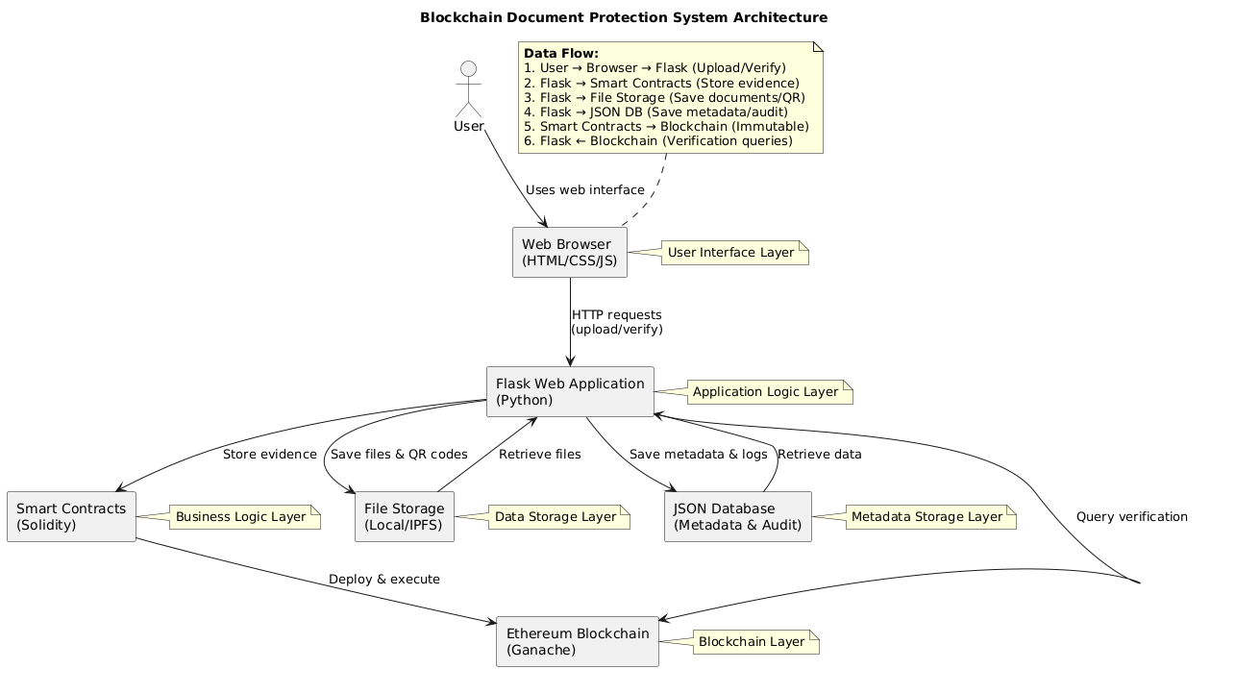

Software Requirements
1. Operating System:
- Windows 10 or higher, macOS 10.15 or higher, or Ubuntu 18.04+
2. Backend Framework:
- Python 3.8+
- Flask 2.3+ (Web framework for APIs and server-side logic)
3. Frontend Framework:
- HTML5, CSS3, JavaScript
- Bootstrap 5.3 for responsive UI design
4. Blockchain & Smart Contracts:
- Ethereum blockchain (local testnet or public testnet)
- Solidity 0.8.x for smart contract development
- Web3.py (Python library for blockchain interaction)
- Truffle Suite (for compiling and deploying smart contracts)
- Ganache (local blockchain for development and testing)
5. Database & Storage:
- JSON files or SQLite for metadata storage
- Optional MySQL or PostgreSQL for production
- IPFS (InterPlanetary File System) for decentralized document storage
- Local or cloud-based file storage
6. Libraries & Dependencies:
- pyqrcode / qrcode / pypng (QR code generation)
- Pillow (PIL) for image processing
- Cryptography libraries (SHA-256 hashing, AES-256 encryption)
- SMTP libraries for email notifications
7. Version Control & Tools:
- Git for version control
- Node.js 14+ and npm for blockchain environment setup

🖥️ Hardware Requirements
Minimum Configuration:
- Processor: Intel Core i3 or equivalent
- RAM: 4 GB
- Storage: 2 GB free disk space
- Network: Internet connection for blockchain syncing and IPFS access
Recommended Configuration:
- Processor: Intel Core i5 or higher
- RAM: 8 GB or more
- Storage: 10 GB free disk space for storing encrypted documents and blockchain data
- Graphics: Integrated GPU (sufficient for UI rendering and QR code generation)
- Network: Stable high-speed internet for smooth blockchain transactions

System Study
The system study is an essential phase in understanding the requirements, limitations, and possibilities of developing a robust solution for secure document management. This phase involves analyzing the current methods of document verification, evaluating their drawbacks, assessing the feasibility of a new system, and defining the functional and technical requirements for an improved solution.
Existing System Analysis
Traditionally, document management relies heavily on centralized storage systems. Documents are typically stored on a local server, cloud storage, or an organizational database. Users can upload, access, and share documents, but the verification process often remains manual or semi-digital, depending on signatures, certificates, or internal approval workflows. While these systems allow for document storage and basic retrieval, they are vulnerable to a variety of risks and inefficiencies.
One of the major challenges in existing systems is data integrity. Centralized storage can be manipulated by unauthorized personnel, either intentionally or accidentally, leading to tampered documents. Verification is often time-consuming, requiring administrative approval or cross-checking with other sources. The limited transparency in user actions and document access makes it difficult to track changes effectively. Additionally, existing systems may lack a proper audit trail, making it challenging to demonstrate compliance or resolve disputes about document authenticity. Handling large files is also cumbersome, especially when transferring, sharing, or storing them in traditional formats.
The main issues observed in traditional systems include the vulnerability of sensitive documents to tampering, inefficient verification procedures, restricted access control, limited transparency, and difficulty in managing large volumes of documents. These shortcomings highlight the need for a more secure, automated, and verifiable system that can maintain document integrity without reliance on centralized authorities.
Feasibility Study
To design an effective document protection system, a thorough feasibility study is necessary. This involves evaluating technical, operational, economic, and social aspects of implementing a blockchain-based solution.
From a technical feasibility perspective, the system leverages established technologies such as Flask for the backend, Ethereum blockchain for immutability, IPFS for decentralized file storage, and SHA-256 hashing for document integrity. The integration of QR codes and a web interface ensures that users can easily upload, verify, and access documents, while role-based access management guarantees secure user permissions.
Operational feasibility ensures that the system is practical for end-users. Administrators can monitor all document activity, investigators can verify evidence efficiently, and public users can check document authenticity in real-time through QR codes. The system’s design supports streamlined document handling, reducing manual effort and potential errors.
In terms of economic feasibility, although the initial setup requires investment in blockchain infrastructure, server resources, and development, the long-term benefits outweigh the costs. By preventing tampering, reducing verification delays, and ensuring compliance with legal standards, the system provides significant value to organizations such as educational institutions, legal firms, and research organizations.
Social feasibility is also critical. The system increases trust among stakeholders by offering transparency and accountability. It ensures that digital documents are secure, verifiable, and compliant with regulatory standards, thereby minimizing disputes and increasing confidence in digital documentation.
System Requirements Analysis
Based on the study of existing systems and their shortcomings, the new system is designed to meet both functional and non-functional requirements. Functional requirements focus on core operations such as uploading, encrypting, and storing documents, generating blockchain-based hashes, producing QR codes for verification, managing role-based access, and maintaining detailed audit trails. Real-time verification ensures that users can instantly confirm document authenticity without waiting for manual approval.
Non-functional requirements emphasize security, reliability, scalability, performance, and usability. Security is enforced through cryptographic hashing, blockchain immutability, and encrypted storage. Reliability ensures the system remains available even under heavy load or during network fluctuations. Scalability allows the system to accommodate multiple users and large volumes of data without degradation in performance. The user interface is designed to be intuitive and responsive, allowing ease of access for users with varying technical expertise.
System Objectives
The primary objective of the proposed blockchain-based document protection system is to provide a secure, transparent, and verifiable solution for managing digital documents. The system aims to eliminate the risks associated with tampering, reduce verification times, and create a robust audit trail for compliance purposes. By decentralizing document storage and leveraging blockchain technology, the system reduces dependency on centralized authorities while ensuring authenticity and integrity.
Other objectives include providing a user-friendly interface for document upload and verification, enabling role-based access for administrators, investigators, and public users, and ensuring real-time verification using blockchain and cryptographic techniques. The system also aims to integrate optional decentralized storage for large files and maintain detailed metadata for auditing purposes.
System Limitations and Constraints
While the proposed system offers significant improvements, it also has certain limitations and constraints. The system depends on blockchain network availability, which may affect real-time verification if the network is offline. Large-scale deployment requires sufficient hardware resources to handle multiple concurrent users and large volumes of data efficiently. Users may require basic technical knowledge to interact with blockchain-related functionalities, especially in non-public or administrative interfaces. Moreover, internet connectivity is mandatory for uploading, verifying, and synchronizing documents with the blockchain network. Despite these constraints, the system is designed to provide maximum security, reliability, and usability within realistic operational conditions.
Process and Approach Using SDLC
The development of a secure blockchain-based document verification system follows a systematic approach under the Software Development Life Cycle (SDLC). SDLC ensures that the software is developed efficiently, meets user requirements, is maintainable, and delivers high-quality performance. The process involves multiple phases, each focusing on a critical aspect of system development.
Requirement Gathering and Analysis
The requirement gathering phase is the foundation of the system. It focuses on identifying what the stakeholders need, understanding the environment, and defining clear objectives. For a blockchain-based document protection system, this phase is crucial because the requirements are not only functional but also highly security-oriented.
During this phase, meetings and discussions are held with stakeholders such as school administrators, legal consultants, investigators, and end users. Their main concerns typically include document integrity, ease of verification, access control, privacy, and auditability.
Key Activities:
- Conduct interviews and workshops with end-users to identify expectations.
- Analyze current document verification processes, noting inefficiencies and risks.
- Identify functional requirements: uploading documents, verifying authenticity, blockchain registration, QR code generation, and role-based permissions.
- Identify non-functional requirements: system security, response time, scalability, and ease of use.
- Perform feasibility studies:
  - Technical feasibility: Can the blockchain solution be implemented with available technology (Flask, Solidity, IPFS)?
  - Operational feasibility: Will users adopt the new system?
  - Economic feasibility: Cost vs. benefit analysis for deployment and maintenance.
- Document all findings in a Software Requirements Specification (SRS) document for approval.
This phase ensures clarity on what the system must achieve, reduces risks, and sets a measurable basis for design and implementation.

System Design
The system design phase translates requirements into a technical blueprint. It defines how the system will function, how modules interact, and how data flows across the system. The design focuses on modularity, security, and maintainability.
Components & Structure:
- Frontend Layer: Designed for ease of use. Includes features for document upload, verification, dashboard views, and audit access. Built using HTML, CSS (Bootstrap), and JavaScript for dynamic behavior.
- Backend Layer: Handles the core logic including file encryption, hash generation, blockchain interaction, and user authentication. Implemented in Flask (Python).
- Blockchain Layer: Smart contracts on Ethereum provide immutable storage of document hashes, ensuring tamper-proof verification.
- Database Layer: Stores document metadata, audit logs, and user details in JSON or SQLite. Supports queries for verification and reports.
- File Storage Layer: Manages encrypted document storage locally or via IPFS for decentralized access.
Design Mechanisms:
- Data Flow Diagrams: Show how data moves from user upload to blockchain storage and verification.
- Sequence Diagrams: Illustrate interactions among frontend, backend, blockchain, and database.
- Security Design: Includes SHA-256 hashing for document integrity, AES encryption for sensitive files, role-based access control, and secure session handling.
- System Architecture Diagrams: Visual representation of modular interaction among all components.
By the end of this phase, a detailed design document is prepared, specifying the architecture, data structures, algorithms, API endpoints, and security protocols.
Frontend Technologies and Approach
The frontend is the interface through which users interact with the system. It focuses on usability, responsiveness, and real-time feedback for document uploads and verification.
- Technologies Used:
  - HTML5 & CSS3: Structure and styling of web pages.
  - Bootstrap 5: For responsive design, ensuring compatibility across desktops, tablets, and mobiles.
  - JavaScript: Client-side scripting for dynamic interactions like QR code scanning and live verification.
  - AJAX: Asynchronous communication with backend APIs for smooth file upload and verification without page reload.
- Approach:
  - The UI is designed to be intuitive with clear options for Upload Document, Verify Document, and View Results.
  - Role-based content rendering ensures that admins, investigators, users, and public verifiers only see features applicable to them.
  - Instant QR code generation allows documents to be verified without login, improving accessibility.

Backend Technologies and Approach
The backend handles core business logic, data processing, and blockchain interaction. Security, encryption, and proper API design are crucial here.
- Technologies Used:
  - Python (Flask Framework): Lightweight web framework for creating RESTful APIs.
  - Web3.py: Python library to interact with Ethereum blockchain smart contracts.
  - SQLite / JSON Database: Metadata storage for documents, user roles, timestamps, and audit logs.
  - Pillow & PyQRCode: Libraries for QR code generation and image processing.
  - PyCryptodome: Provides encryption (AES) and hashing (SHA-256) for document security.
- Approach:
  - The backend receives documents from users, generates SHA-256 hash, encrypts files, and saves them in storage.
  - Metadata including hash, owner, and timestamp is stored in the database for quick access.
  - The backend communicates with the smart contract to register the document hash on blockchain.
  - Verification requests compare local hash with blockchain hash to determine authenticity.

Blockchain Technologies and Approach
The blockchain layer ensures immutability and tamper-proof verification of documents. It is the core security component.
- Technologies Used:
  - Ethereum Blockchain: Public blockchain for storing document hashes.
  - Solidity: Language to write smart contracts that manage hash registration and verification.
  - Ganache: Local blockchain environment for testing and development.
  - Truffle Suite: Framework for smart contract compilation, deployment, and testing.
- Approach:
  - Each document uploaded is hashed and recorded in a smart contract.
  - Smart contracts provide methods to verify if a document hash exists and is valid.
  - Blockchain ensures immutability: once a hash is registered, it cannot be altered or deleted.
  - The backend queries blockchain for real-time verification, providing proof of authenticity.

Storage and Database Technologies
Efficient storage is essential for large documents and metadata management.
- Technologies Used:
  - Local File System: For small-scale storage and development.
  - IPFS (InterPlanetary File System): Optional decentralized storage for large files.
  - SQLite / JSON Files: Store metadata, user details, and audit logs.
- Approach:
  - Files are encrypted before storage to protect sensitive data.
  - Metadata is separated from actual documents to optimize query performance.
  - Decentralized storage via IPFS ensures documents remain accessible even if local storage fails.

Security Approach
Security is embedded across all layers.
- Hashing & Encryption: SHA-256 hashes ensure file integrity, AES encryption secures file content.
- Role-Based Access Control: Admins, investigators, and public verifiers have defined privileges.
- Secure Communication: HTTPS ensures safe data transfer.
- Audit Trail: All actions are logged with timestamp, user, and action type.
- Zero-Knowledge Proofs (Optional): Privacy-preserving verification without revealing sensitive content.

Overall System Approach
The system follows a modular and layered architecture:
- User Interaction Layer (Frontend): Users upload or verify documents using a responsive web interface.
- Application Layer (Backend): Handles encryption, hash generation, database operations, and blockchain communication.
- Blockchain Layer: Records immutable hashes of documents for verification.
- Storage Layer: Securely stores encrypted documents in local or decentralized storage.
- Database Layer: Maintains metadata and audit logs for easy tracking.
Data Flow Mechanism:
- Document uploaded → Backend generates hash → Encrypt & store file → Store hash & metadata → Register hash in blockchain → Generate QR code → User verification requests compare hashes with blockchain → Display authenticity status.
Unified Modeling Language (UML)
1. Introduction to UML
- UML (Unified Modeling Language) is a standardized modeling language used in software engineering.
- It provides a way to visualize, design, and document the structure and behavior of software systems.
2. Purpose of UML
- To provide a common language for developers, analysts, and stakeholders.
- To help in requirement analysis, system design, and documentation.
- To support both object-oriented programming and software development life cycle (SDLC) phases.
3. Features of UML
- Visual Modeling: Provides graphical notation.
- Standardization: Accepted globally as a modeling language.
- Abstraction: Represents real-world problems at different abstraction levels.
- Scalability: Useful for small as well as enterprise-scale projects.

1. Use Case Diagram
Definition
A Use Case Diagram represents the functional requirements of a system. It shows what the system should do from the user’s perspective.
Key Elements
- Actors: Users or external systems that interact with the system.
- Use Cases: Functionalities or services the system provides.
- Relationships: Associations between actors and use cases.
Purpose
- Captures system requirements.
- Provides a high-level overview of functionalities.
- Helps stakeholders understand what the system does without technical details.
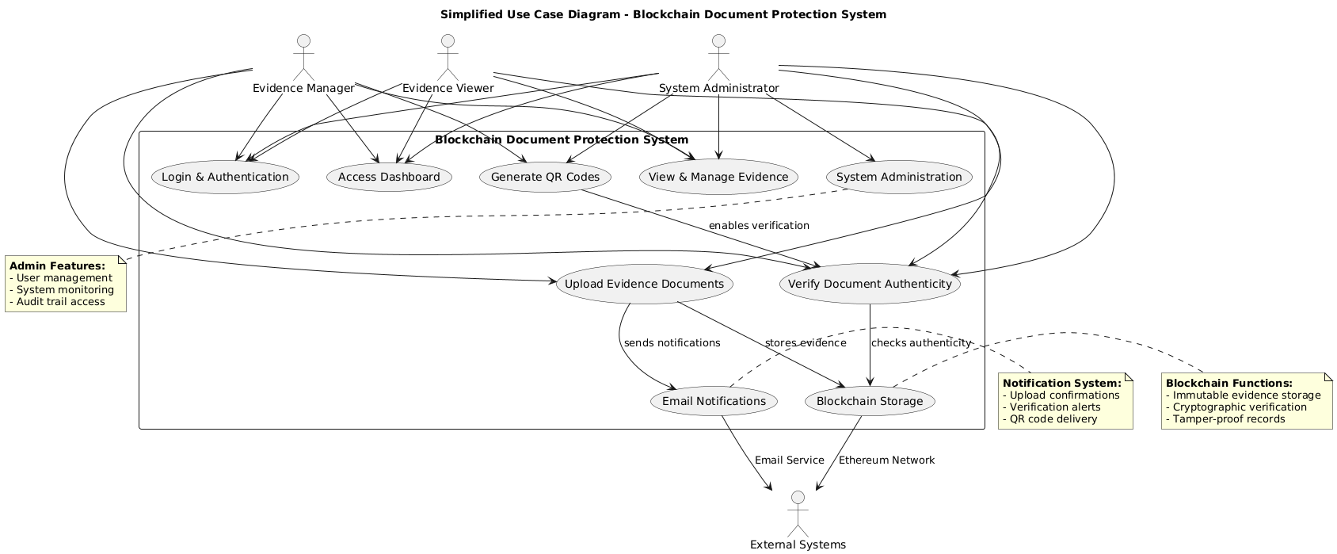

Activity Diagram
Definition
An Activity Diagram models the workflow of activities within a system or process. It is like a flowchart showing the sequence of actions.
Key Elements
- Activities (Actions): Tasks being performed.
- Decision Nodes: Points where alternative paths can be taken.
- Start/End Nodes: Beginning and end of a workflow.
- Swimlanes: Divides activities among different actors or roles.
Purpose
- Describes business processes or system workflows.
- Helps in understanding how tasks are performed.
- Useful in modeling algorithms and use case flows.
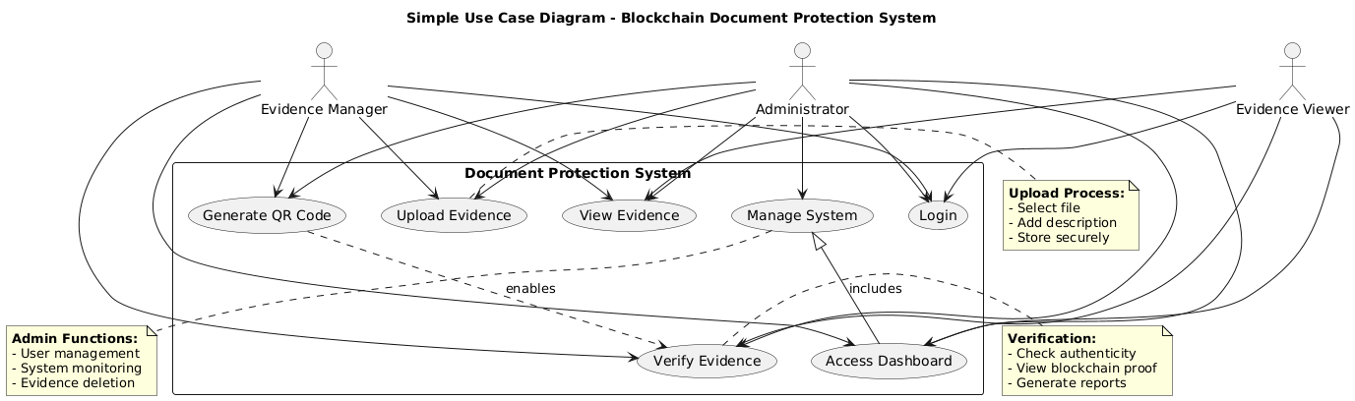

Sequence Diagram
Definition
A Sequence Diagram shows the time-ordered interaction between objects. It focuses on how messages are exchanged step by step.
Key Elements
- Objects/Participants: Represented as vertical lifelines.
- Messages: Horizontal arrows showing communication.
- Activation Bars: Indicate the duration an object is active.
- Time Flow: Moves from top to bottom.
Purpose
- Models object interactions in chronological order.
- Helps developers design methods, API calls, and logic flows.
- Useful for understanding execution order of operations.

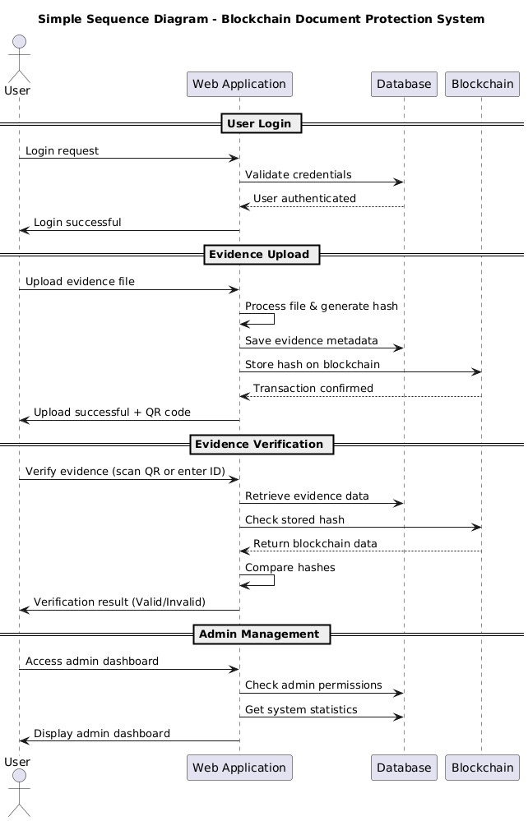
Collaboration Diagram (Communication Diagram)
Definition
A Collaboration Diagram (now called Communication Diagram in UML 2.x) shows the interactions between objects and how they are linked. Unlike sequence diagrams, it emphasizes relationships rather than time.
Key Elements
- Objects: Represented as nodes.
- Links: Associations between objects.
- Messages: Numbered interactions exchanged between objects.
Purpose
- Focuses on structural organization of interacting objects.
- Complements sequence diagrams by showing which objects communicate.
- Useful for understanding object relationships in a system.
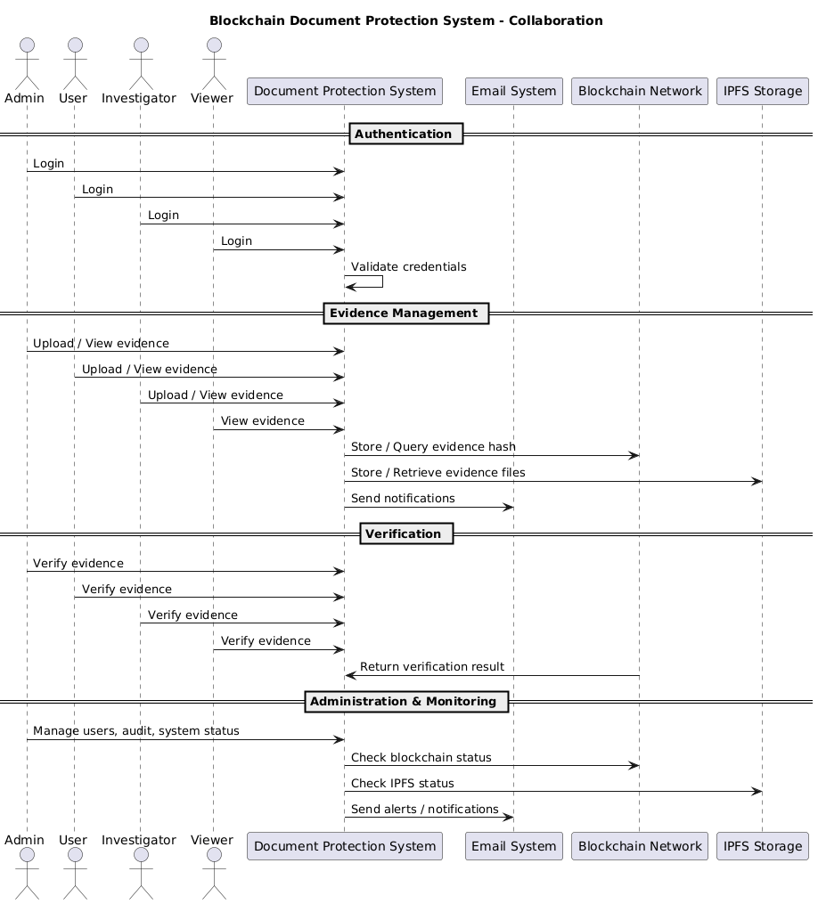

What Is a Blockchain?
A blockchain is a distributed database or ledger shared across a computer network's nodes. While it is best known for its crucial role in cryptocurrency systems, maintaining a secure and decentralized record of transactions, blockchains are not limited to cryptocurrency uses. Blockchains can be used to make data in any industry immutable, meaning it cannot be altered.
Since a block can’t be changed, the only trust needed is at the point where a user or program enters data. This reduces the need for trusted third parties, such as auditors or other humans, who add costs and can make mistakes.
Since Bitcoin's introduction in 2009, blockchain use has exploded due to the creation of various cryptocurrencies, decentralized finance (DeFi) applications, non-fungible tokens (NFTs), and smart contracts. Bitcoin and other popular cryptocurrencies, such as Ethereum and Solana, can be purchased through leading crypto exchanges.
Key Takeaways
- Blockchain is a type of shared database that differs from a typical database in the way it stores information; blockchains store data in blocks linked together via cryptography.
- Different types of information can be stored on a blockchain, but the most common use has been as a transaction ledger.
- In Bitcoin’s case, the blockchain is decentralized, so no single person or group has control—instead, all users collectively retain control.
- Decentralized blockchains are immutable, which means that the data entered is irreversible. For Bitcoin, transactions are permanently recorded and viewable to anyone.
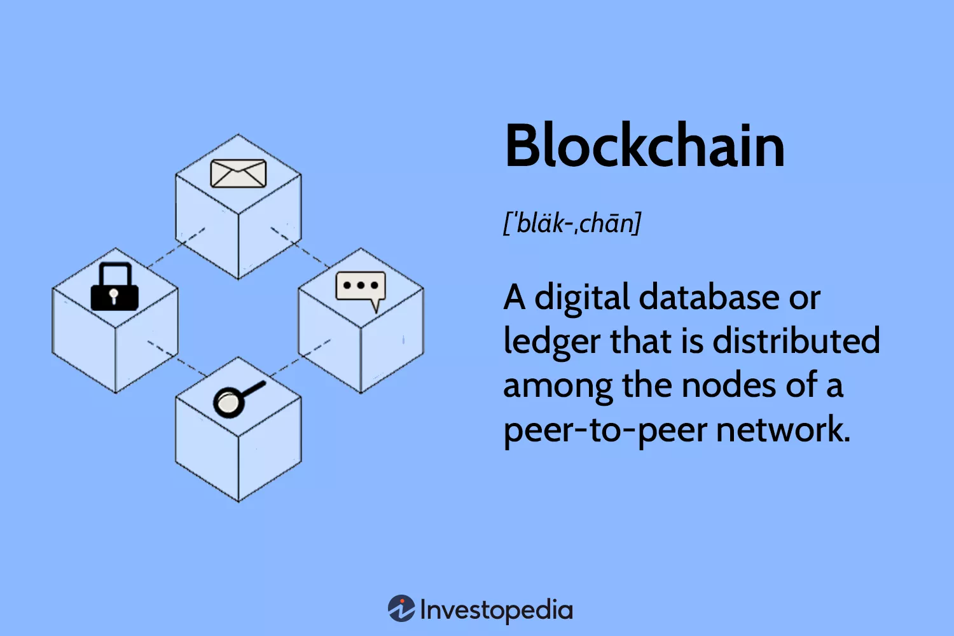

How Does a Blockchain Work?
You might be familiar with spreadsheets or databases. A blockchain is somewhat similar because it is a database where information is entered and stored. The key difference between a traditional database or spreadsheet and a blockchain is how the data is structured and accessed.
A blockchain consists of programs called scripts that conduct the tasks you usually would in a database: entering and accessing information, and saving and storing it somewhere. A blockchain is distributed, meaning multiple copies are saved on many machines and must match for it to be valid.
The Bitcoin blockchain collects transaction information and enters it into a 4MB file called a block (different blockchains have different-sized blocks). Once the block is full, the block data is run through a cryptographic hash function, which creates a hexadecimal number called the block header hash.
The hash is then entered into the following block header and encrypted with the other information in that block's header, creating a chain of blocks, hence the name “blockchain.”
Transaction Process
Transactions follow a specific process, depending on the blockchain. For example, on Bitcoin's blockchain, if you initiate a transaction using your cryptocurrency wallet—the application that provides an interface for the blockchain—it starts a sequence of events.
In Bitcoin, your transaction is sent to a memory pool, where it is stored and queued until a miner picks it up. Once it is entered into a block and the block fills up with transactions, it is closed, and the mining begins.
Investopedia
Every node in the network proposes its own blocks in this way because it chooses different transactions. Each works on their own blocks, trying to find a solution to the difficulty target, using the "nonce," short for number used once.
The nonce value is a field in the block header that is changeable, and its value incrementally increases with every mining attempt. If the resulting hash isn't equal to or less than the target hash, a value of one is added to the nonce, a new hash is generated, and so on. The nonce rolls over about every 4.5 billion attempts (which takes less than one second) and uses another value called the extra nonce as an additional counter. This continues until a miner generates a valid hash, winning the race and receiving the reward.
Pros and Cons of Blockchain
For all of its complexity, blockchain’s potential as a decentralized form of record-keeping is almost without limit. From greater user privacy and heightened security to lower processing fees and fewer errors, blockchain technology may very well see applications beyond those outlined above. But there are also some disadvantages.
Pros
- Improved accuracy by removing human involvement in verification
- Cost reductions by eliminating third-party verification
- Decentralization makes it harder to tamper with
- Transactions are secure, private, and efficient
- Transparent technology
- Provides a banking alternative and a way to secure personal information for citizens of countries with unstable or underdeveloped governments
Cons
- Significant technology cost associated with some blockchains
- Low number of transactions per second
- History of use in illicit activities, such as on the dark web
- Regulation varies by jurisdiction and remains uncertain
- Data storage limitations
Benefits of Blockchains
Accuracy of the Chain
Transactions on the blockchain network are approved by thousands of computers and devices. This removes almost all people from the verification process, resulting in less human error and an accurate record of information. Even if a computer on the network were to make a computational mistake, the error would only be made to one copy of the blockchain and not be accepted by the rest of the network.
Cost Reductions
Typically, consumers pay a bank to verify a transaction or a notary to sign a document. Blockchain eliminates the need for third-party verification—and, with it, their associated costs. For example, business owners incur a small fee when they accept credit card payments because banks and payment-processing companies have to process those transactions. Bitcoin, on the other hand, does not have a central authority and has limited transaction fees.
Decentralization
Blockchain does not store any information in a central location. Instead, it is copied and spread across a network of computers. Whenever a new block is added to the blockchain, every computer on the network updates its blockchain to reflect the change.
By spreading that information across a network, rather than storing it in one central database, blockchain becomes significantly more difficult to tamper with.
Efficient Transactions
Transactions placed through a central authority can take up to a few days to settle. If you attempt to deposit a check on Friday evening, for example, you may not actually see funds in your account until Monday morning. Financial institutions operate during business hours, usually five days a week—but a blockchain runs 24 hours a day, seven days a week, and 365 days a year.
On some blockchains, transactions can be completed and considered secure in minutes. This is particularly useful for cross-border trades, which usually take much longer because of time zone issues and the fact that all parties must confirm payment processing.
Private Transactions
Many blockchain networks operate as public databases, meaning anyone with an internet connection can view a list of the network’s transaction history. Although users can access transaction details, they cannot access identifying information about the users making those transactions. It is a common misconception that blockchain networks like Bitcoin are fully anonymous; they are actually pseudonymous because there is a viewable address that can be associated with a user if the information gets out.
Secure Transactions
Once a transaction is recorded, its authenticity must be verified by the blockchain network. After the transaction is validated, it is added to the blockchain block. Each block on the blockchain contains its unique hash and the unique hash of the block before it. Therefore, the blocks cannot be altered once the network confirms them.
Transparency
Many blockchains are entirely open source. This means that everyone can view its code. This gives auditors the ability to review cryptocurrencies like Bitcoin for security. However, it also means there is no real authority on who controls Bitcoin’s code or how it is edited. Because of this, anyone can suggest changes or upgrades to the system. If a majority of the network users agree that the new version of the code with the upgrade is sound and worthwhile, then Bitcoin can be updated.
Private or permissioned blockchains may not allow for public transparency, depending on how they are designed or their purpose. These types of blockchains might be made only for an organization that wishes to track data accurately without allowing anyone outside of the permissioned users to see it.
Alternatively, there might come a point where publicly traded companies are required to provide investors with financial transparency through a regulator-approved blockchain reporting system. Using blockchains in business accounting and financial reporting would prevent companies from altering their financials to appear more profitable than they really are.
Banking the Unbanked
Perhaps the most profound facet of blockchain and cryptocurrency is the ability for anyone, regardless of ethnicity, gender, location, or cultural background, to use it. According to The World Bank, an estimated 1.3 billion adults do not have bank accounts or any means of storing their money or wealth.11 Moreover, nearly all of these individuals live in developing countries where the economy is in its infancy and entirely dependent on cash.
These people are often paid in physical cash. They then need to store this physical cash in hidden locations in their homes or other places, incentivizing robbers or violence. While not impossible to steal, crypto makes it more difficult for would-be thieves.
Drawbacks of Blockchains
Technology Cost
Although blockchain can save users money on transaction fees, the technology is far from free. For example, the Bitcoin network's proof-of-work system to validate transactions consumes vast amounts of computational power. In the real world, the energy consumed by the millions of devices on the Bitcoin network is more than what Finland uses.12
Some solutions to these issues are beginning to arise. For example, bitcoin-mining farms have been set up to use solar power, excess natural gas from fracking sites, or energy from wind farms.
Speed and Data Inefficiency
Bitcoin is a perfect case study of the inefficiencies of blockchain. Bitcoin's PoW system takes about 10 minutes to add a new block to the blockchain. At that rate, it's estimated that the blockchain network can only manage up to 10 transactions per second (TPS).13 Although other cryptocurrencies, such as Ethereum, perform better than Bitcoin, the complex structure of blockchain still limits them. Legacy brand Visa, for context, can process 65,000 TPS.14
Solutions to this issue have been in development for years. There are currently blockchain projects that claim tens of thousands of TPS. Ethereum is rolling out a series of upgrades that include data sampling, binary large objects (BLOBs), and rollups. These improvements are expected to increase network participation, reduce congestion, decrease fees, and increase transaction speeds.15
The other issue with many blockchains is that each block can only hold so much data. The block size debate has been and continues to be one of the most pressing issues for future blockchains' scalability.
Illegal Activity
While confidentiality on the blockchain network protects users from hacks and preserves privacy, it also allows for illegal trading and activity on the blockchain network. The most cited example of blockchain being used for illicit transactions is probably the Silk Road, an online dark web illegal-drug and money laundering marketplace operating from February 2011 until October 2013, when the FBI shut it down.16
The dark web allows users to buy and sell illegal goods without being tracked by using the Tor Browser and make illicit purchases in Bitcoin or other cryptocurrencies. This is in stark contrast to U.S. regulations, which require financial service providers to obtain information about their customers when they open an account. They are supposed to verify the identity of each customer and confirm that they do not appear on any list of known or suspected terrorist organizations.17
Important
Illicit activity accounted for only 0.34% of all cryptocurrency transactions in 2023.18
This system can be seen as both a pro and a con. It gives anyone access to financial accounts, but allows criminals to transact more easily. Many have argued that the good uses of crypto, like banking the unbanked, outweigh the bad uses of cryptocurrency, especially when most illegal activity is still accomplished through untraceable cash.
Warning
Public perception of blockchain and cryptocurrencies, in particular, remains uneasy. High-profile collapses of once-trusted cryptocurrency brokers, such as Mt. Gox back in 2014, or FTX in November 2022, the persistence of various crypto scams, and general skepticism towards new technology and its bold promises, all contribute to ongoing public skepticism about a decentralized future. As of 2024, 39% of Americans still say they will never purchase a cryptocurrency.19
Regulation
Many in the crypto space have expressed concerns about government regulation of cryptocurrencies. Several jurisdictions are tightening control over certain types of crypto and other virtual currencies. However, no regulations have yet been introduced that focus on restricting blockchain uses and development, only certain products created using it.
Data Storage
Another significant implication of blockchains is that they require storage. This may not appear to be substantial because we already store lots of information and data. However, as time passes, the growing blockchain use will require more storage, especially on blockchains where nodes store the entire chain.
Currently, data storage is centralized in large centers. But if the world transitions to blockchain for every industry and use, its exponentially growing size would require more advanced techniques to make storage more efficient, or force participants to continually upgrade their storage.
This could become significantly more expensive in terms of both money and physical space needed, as the Bitcoin blockchain itself was over 650 gigabytes as of September 2025, and this blockchain records only Bitcoin transactions.20 This is small compared to the amount of data stored in large data centers, but a growing number of blockchains will only add to the amount of storage already required for the digital world.21
What Exactly Is a Blockchain?
Simply put, a blockchain is a shared database or ledger. Bits of data are stored in files known as blocks, and each network node has a replica of the entire database. Security is ensured since the majority of nodes will not accept a change if someone tries to edit or delete an entry in one copy of the ledger.
What Is a Blockchain in Easy Terms?
Imagine you typed some information into a document on your computer and sent it through a program that gave you a string of numbers and letters (called hashing, with the string called a hash). You add this hash to the beginning of another document and type information into it. Again, you use the program to create a hash, which you add to the following document.
Each hash is a representation of the previous document, which creates a chain of encoded documents that cannot be altered without changing the hash. Each document is stored on computers in a network. This network of programs compares each document with the ones they have stored and accepts them as valid based on the hashes they generate. If a document doesn't generate a hash that is a match, that document is rejected by the network.

Environment Setup
What is Python :-
Below are some facts about Python.
Python is currently the most widely used multi-purpose, high-level programming language.
Python allows programming in Object-Oriented and Procedural paradigms. Python programs generally are smaller than other programming languages like Java.
Programmers have to type relatively less and indentation requirement of the language, makes them readable all the time.
Python language is being used by almost all tech-giant companies like – Google, Amazon, Facebook, Instagram, Dropbox, Uber… etc.
The biggest strength of Python is huge collection of standard library which can be used for the following .
  - Machine Learning
  - GUI Applications (like Kivy, Tkinter, PyQt etc. )
  - Web frameworks like Django (used by YouTube, Instagram, Dropbox)
  - Image processing (like Opencv, Pillow)
  - Web scraping (like Scrapy, BeautifulSoup, Selenium)
  - Test frameworks
  - Multimedia
Advantages of Python :-
Let’s see how Python dominates over other languages.
1. Extensive Libraries
Python downloads with an extensive library and it contain code for various purposes like regular expressions, documentation-generation, unit-testing, web browsers, threading, databases, CGI, email, image manipulation, and more. So, we don’t have to write the complete code for that manually.
2. Extensible
As we have seen earlier, Python can be extended to other languages. You can write some of your code in languages like C++ or C. This comes in handy, especially in projects.
3. Embeddable
Complimentary to extensibility, Python is embeddable as well. You can put your Python code in your source code of a different language, like C++. This lets us add scripting capabilities to our code in the other language.
4. Improved Productivity
The language’s simplicity and extensive libraries render programmers more productive than languages like Java and C++ do. Also, the fact that you need to write less and get more things done.
5. IOT Opportunities
Since Python forms the basis of new platforms like Raspberry Pi, it finds the future bright for the Internet Of Things. This is a way to connect the language with the real world.
6. Simple and Easy
When working with Java, you may have to create a class to print ‘Hello World’. But in Python, just a print statement will do. It is also quite easy to learn, understand, and code. This is why when people pick up Python, they have a hard time adjusting to other more verbose languages like Java.
7. Readable
Because it is not such a verbose language, reading Python is much like reading English. This is the reason why it is so easy to learn, understand, and code. It also does not need curly braces to define blocks, and indentation is mandatory. This further aids the readability of the code.
8. Object-Oriented
This language supports both the procedural and object-oriented programming paradigms. While functions help us with code reusability, classes and objects let us model the real world. A class allows the encapsulation of data and functions into one.
9. Free and Open-Source
Like we said earlier, Python is freely available. But not only can you download Python for free, but you can also download its source code, make changes to it, and even distribute it. It downloads with an extensive collection of libraries to help you with your tasks.
10. Portable
When you code your project in a language like C++, you may need to make some changes to it if you want to run it on another platform. But it isn’t the same with Python. Here, you need to code only once, and you can run it anywhere. This is called Write Once Run Anywhere (WORA). However, you need to be careful enough not to include any system-dependent features.
11. Interpreted
Lastly, we will say that it is an interpreted language. Since statements are executed one by one, debugging is easier than in compiled languages.
Any doubts till now in the advantages of Python? Mention in the comment section.
History of Python : -

What do the alphabet and the programming language Python have in common? Right, both start with ABC. If we are talking about ABC in the Python context, it's clear that the programming language ABC is meant. ABC is a general-purpose programming language and programming environment, which had been developed in the Netherlands, Amsterdam, at the CWI (Centrum Wiskunde &Informatica). The greatest achievement of ABC was to influence the design of Python.Python was conceptualized in the late 1980s. Guido van Rossum worked that time in a project at the CWI, called Amoeba, a distributed operating system. In an interview with Bill Venners¹, Guido van Rossum said: "In the early 1980s, I worked as an implementer on a team building a language called ABC at Centrum voor Wiskunde en Informatica (CWI).
I don't know how well people know ABC's influence on Python. I try to mention ABC's influence because I'm indebted to everything I learned during that project and to the people who worked on it."Later on in the same Interview, Guido van Rossum continued: "I remembered all my experience and some of my frustration with ABC. I decided to try to design a simple scripting language that possessed some of ABC's better properties, but without its problems. So I started typing. I created a simple virtual machine, a simple parser, and a simple runtime. I made my own version of the various ABC parts that I liked. I created a basic syntax, used indentation for statement grouping instead of curly braces or begin-end blocks, and developed a small number of powerful data types: a hash table (or dictionary, as we call it), a list, strings, and numbers."

What is Machine Learning : -
Before we take a look at the details of various machine learning methods, let's start by looking at what machine learning is, and what it isn't. Machine learning is often categorized as a subfield of artificial intelligence, but I find that categorization can often be misleading at first brush. The study of machine learning certainly arose from research in this context, but in the data science application of machine learning methods, it's more helpful to think of machine learning as a means of building models of data.
Fundamentally, machine learning involves building mathematical models to help understand data. "Learning" enters the fray when we give these models tunable parameters that can be adapted to observed data; in this way the program can be considered to be "learning" from the data.
Once these models have been fit to previously seen data, they can be used to predict and understand aspects of newly observed data. I'll leave to the reader the more philosophical digression regarding the extent to which this type of mathematical, model-based "learning" is similar to the "learning" exhibited by the human brain.Understanding the problem setting in machine learning is essential to using these tools effectively, and so we will start with some broad categorizations of the types of approaches we'll discuss here.
Categories Of Machine Leaning :-
At the most fundamental level, machine learning can be categorized into two main types: supervised learning and unsupervised learning.
Supervised learning involves somehow modeling the relationship between measured features of data and some label associated with the data; once this model is determined, it can be used to apply labels to new, unknown data. This is further subdivided into classification tasks and regression tasks: in classification, the labels are discrete categories, while in regression, the labels are continuous quantities. We will see examples of both types of supervised learning in the following section.
Unsupervised learning involves modeling the features of a dataset without reference to any label, and is often described as "letting the dataset speak for itself." These models include tasks such as clustering and dimensionality reduction.
Clustering algorithms identify distinct groups of data, while dimensionality reduction algorithms search for more succinct representations of the data. We will see examples of both types of unsupervised learning in the following section.
Need for Machine Learning
Human beings, at this moment, are the most intelligent and advanced species on earth because they can think, evaluate and solve complex problems. On the other side, AI is still in its initial stage and haven’t surpassed human intelligence in many aspects. Then the question is that what is the need to make machine learn? The most suitable reason for doing this is, “to make decisions, based on data, with efficiency and scale”.
Lately, organizations are investing heavily in newer technologies like Artificial Intelligence, Machine Learning and Deep Learning to get the key information from data to perform several real-world tasks and solve problems. We can call it data-driven decisions taken by machines, particularly to automate the process. These data-driven decisions can be used, instead of using programing logic, in the problems that cannot be programmed inherently. The fact is that we can’t do without human intelligence, but other aspect is that we all need to solve real-world problems with efficiency at a huge scale. That is why the need for machine learning arises.
Challenges in Machines Learning :
While Machine Learning is rapidly evolving, making significant strides with cybersecurity and autonomous cars, this segment of AI as whole still has a long way to go. The reason behind is that ML has not been able to overcome number of challenges. The challenges that ML is facing currently are −
Quality of data − Having good-quality data for ML algorithms is one of the biggest challenges. Use of low-quality data leads to the problems related to data preprocessing and feature extraction.
Time-Consuming task − Another challenge faced by ML models is the consumption of time especially for data acquisition, feature extraction and retrieval.
Lack of specialist persons − As ML technology is still in its infancy stage, availability of expert resources is a tough job.
No clear objective for formulating business problems − Having no clear objective and well-defined goal for business problems is another key challenge for ML because this technology is not that mature yet.
Issue of overfitting & underfitting − If the model is overfitting or underfitting, it cannot be represented well for the problem.
Curse of dimensionality − Another challenge ML model faces is too many features of data points. This can be a real hindrance.
Difficulty in deployment − Complexity of the ML model makes it quite difficult to be deployed in real life.
Applications of Machines Learning :-
Machine Learning is the most rapidly growing technology and according to researchers we are in the golden year of AI and ML. It is used to solve many real-world complex problems which cannot be solved with traditional approach. Following are some real-world applications of ML −
- Emotion analysis
- Sentiment analysis
- Error detection and prevention
- Weather forecasting and prediction
- Stock market analysis and forecasting
- Speech synthesis
- Speech recognition
- Customer segmentation
- Object recognition
- Fraud detection
- Fraud prevention
- Recommendation of products to customer in online shopping
How to Start Learning Machine Learning?
Arthur Samuel coined the term “Machine Learning” in 1959 and defined it as a “Field of study that gives computers the capability to learn without being explicitly programmed”.
And that was the beginning of Machine Learning! In modern times, Machine Learning is one of the most popular (if not the most!) career choices. According to Indeed, Machine Learning Engineer Is The Best Job of 2019 with a 344% growth and an average base salary of $146,085 per year.
But there is still a lot of doubt about what exactly is Machine Learning and how to start learning it? So this article deals with the Basics of Machine Learning and also the path you can follow to eventually become a full-fledged Machine Learning Engineer. Now let’s get started!!!
How to start learning ML?
This is a rough roadmap you can follow on your way to becoming an insanely talented Machine Learning Engineer. Of course, you can always modify the steps according to your needs to reach your desired end-goal!
Step 1 – Understand the Prerequisites
In case you are a genius, you could start ML directly but normally, there are some prerequisites that you need to know which include Linear Algebra, Multivariate Calculus, Statistics, and Python. And if you don’t know these, never fear! You don’t need a Ph.D. degree in these topics to get started but you do need a basic understanding.
(a) Learn Linear Algebra and Multivariate Calculus
Both Linear Algebra and Multivariate Calculus are important in Machine Learning. However, the extent to which you need them depends on your role as a data scientist. If you are more focused on application heavy machine learning, then you will not be that heavily focused on maths as there are many common libraries available. But if you want to focus on R&D in Machine Learning, then mastery of Linear Algebra and Multivariate Calculus is very important as you will have to implement many ML algorithms from scratch.
(b) Learn Statistics
Data plays a huge role in Machine Learning. In fact, around 80% of your time as an ML expert will be spent collecting and cleaning data. And statistics is a field that handles the collection, analysis, and presentation of data. So it is no surprise that you need to learn it!!!
Some of the key concepts in statistics that are important are Statistical Significance, Probability Distributions, Hypothesis Testing, Regression, etc. Also, Bayesian Thinking is also a very important part of ML which deals with various concepts like Conditional Probability, Priors, and Posteriors, Maximum Likelihood, etc.
(c) Learn Python
Some people prefer to skip Linear Algebra, Multivariate Calculus and Statistics and learn them as they go along with trial and error. But the one thing that you absolutely cannot skip is Python! While there are other languages you can use for Machine Learning like R, Scala, etc. Python is currently the most popular language for ML. In fact, there are many Python libraries that are specifically useful for Artificial Intelligence and Machine Learning such as Keras, TensorFlow, Scikit-learn, etc.
So if you want to learn ML, it’s best if you learn Python! You can do that using various online resources and courses such as Fork Python available Free on GeeksforGeeks.
Step 2 – Learn Various ML Concepts
Now that you are done with the prerequisites, you can move on to actually learning ML (Which is the fun part!!!) It’s best to start with the basics and then move on to the more complicated stuff. Some of the basic concepts in ML are:
(a) Terminologies of Machine Learning
- Model – A model is a specific representation learned from data by applying some machine learning algorithm. A model is also called a hypothesis.
- Feature – A feature is an individual measurable property of the data. A set of numeric features can be conveniently described by a feature vector. Feature vectors are fed as input to the model. For example, in order to predict a fruit, there may be features like color, smell, taste, etc.
- Target (Label) – A target variable or label is the value to be predicted by our model. For the fruit example discussed in the feature section, the label with each set of input would be the name of the fruit like apple, orange, banana, etc.
- Training – The idea is to give a set of inputs(features) and it’s expected outputs(labels), so after training, we will have a model (hypothesis) that will then map new data to one of the categories trained on.
- Prediction – Once our model is ready, it can be fed a set of inputs to which it will provide a predicted output(label).
(b) Types of Machine Learning
- Supervised Learning – This involves learning from a training dataset with labeled data using classification and regression models. This learning process continues until the required level of performance is achieved.
- Unsupervised Learning – This involves using unlabelled data and then finding the underlying structure in the data in order to learn more and more about the data itself using factor and cluster analysis models.
- Semi-supervised Learning – This involves using unlabelled data like Unsupervised Learning with a small amount of labeled data. Using labeled data vastly increases the learning accuracy and is also more cost-effective than Supervised Learning.
- Reinforcement Learning – This involves learning optimal actions through trial and error. So the next action is decided by learning behaviors that are based on the current state and that will maximize the reward in the future.
Advantages of Machine learning :-
1. Easily identifies trends and patterns -
Machine Learning can review large volumes of data and discover specific trends and patterns that would not be apparent to humans. For instance, for an e-commerce website like Amazon, it serves to understand the browsing behaviors and purchase histories of its users to help cater to the right products, deals, and reminders relevant to them. It uses the results to reveal relevant advertisements to them.
2. No human intervention needed (automation)
With ML, you don’t need to babysit your project every step of the way. Since it means giving machines the ability to learn, it lets them make predictions and also improve the algorithms on their own. A common example of this is anti-virus softwares; they learn to filter new threats as they are recognized. ML is also good at recognizing spam.
3. Continuous Improvement
As ML algorithms gain experience, they keep improving in accuracy and efficiency. This lets them make better decisions. Say you need to make a weather forecast model. As the amount of data you have keeps growing, your algorithms learn to make more accurate predictions faster.
4. Handling multi-dimensional and multi-variety data
Machine Learning algorithms are good at handling data that are multi-dimensional and multi-variety, and they can do this in dynamic or uncertain environments.
5. Wide Applications
You could be an e-tailer or a healthcare provider and make ML work for you. Where it does apply, it holds the capability to help deliver a much more personal experience to customers while also targeting the right customers.
Disadvantages of Machine Learning :-
1. Data Acquisition
Machine Learning requires massive data sets to train on, and these should be inclusive/unbiased, and of good quality. There can also be times where they must wait for new data to be generated.
2. Time and Resources
ML needs enough time to let the algorithms learn and develop enough to fulfill their purpose with a considerable amount of accuracy and relevancy. It also needs massive resources to function. This can mean additional requirements of computer power for you.
3. Interpretation of Results
Another major challenge is the ability to accurately interpret results generated by the algorithms. You must also carefully choose the algorithms for your purpose.
4. High error-susceptibility
Machine Learning is autonomous but highly susceptible to errors. Suppose you train an algorithm with data sets small enough to not be inclusive. You end up with biased predictions coming from a biased training set. This leads to irrelevant advertisements being displayed to customers. In the case of ML, such blunders can set off a chain of errors that can go undetected for long periods of time. And when they do get noticed, it takes quite some time to recognize the source of the issue, and even longer to correct it.

Python Development Steps : -
Guido Van Rossum published the first version of Python code (version 0.9.0) at alt.sources in February 1991. This release included already exception handling, functions, and the core data types of list, dict, str and others. It was also object oriented and had a module system.
Python version 1.0 was released in January 1994. The major new features included in this release were the functional programming tools lambda, map, filter and reduce, which Guido Van Rossum never liked.Six and a half years later in October 2000, Python 2.0 was introduced. This release included list comprehensions, a full garbage collector and it was supporting unicode.Python flourished for another 8 years in the versions 2.x before the next major release as Python 3.0 (also known as "Python 3000" and "Py3K") was released. Python 3 is not backwards compatible with Python 2.x.

The emphasis in Python 3 had been on the removal of duplicate programming constructs and modules, thus fulfilling or coming close to fulfilling the 13th law of the Zen of Python: "There should be one -- and preferably only one -- obvious way to do it."Some changes in Python 7.3:
- Print is now a function
- Views and iterators instead of lists
- The rules for ordering comparisons have been simplified. E.g. a heterogeneous list cannot be sorted, because all the elements of a list must be comparable to each other.
- There is only one integer type left, i.e. int. long is int as well.
- The division of two integers returns a float instead of an integer. "//" can be used to have the "old" behaviour.
- Text Vs. Data Instead Of Unicode Vs. 8-bit
Purpose :-
We demonstrated that our approach enables successful segmentation of intra-retinal layers—even with low-quality images containing speckle noise, low contrast, and different intensity ranges throughout—with the assistance of the ANIS feature.
Python
Python is an interpreted high-level programming language for general-purpose programming. Created by Guido van Rossum and first released in 1991, Python has a design philosophy that emphasizes code readability, notably using significant whitespace.
Python features a dynamic type system and automatic memory management. It supports multiple programming paradigms, including object-oriented, imperative, functional and procedural, and has a large and comprehensive standard library.
- Python is Interpreted − Python is processed at runtime by the interpreter. You do not need to compile your program before executing it. This is similar to PERL and PHP.
- Python is Interactive − you can actually sit at a Python prompt and interact with the interpreter directly to write your programs.
Python also acknowledges that speed of development is important. Readable and terse code is part of this, and so is access to powerful constructs that avoid tedious repetition of code. Maintainability also ties into this may be an all but useless metric, but it does say something about how much code you have to scan, read and/or understand to troubleshoot problems or tweak behaviors. This speed of development, the ease with which a programmer of other languages can pick up basic Python skills and the huge standard library is key to another area where Python excels. All its tools have been quick to implement, saved a lot of time, and several of them have later been patched and updated by people with no Python background - without breaking.
Modules Used in Project :-
Tensorflow
TensorFlow is a free and open-source software library for dataflow and differentiable programming across a range of tasks. It is a symbolic math library, and is also used for machine learning applications such as neural networks. It is used for both research and production at Google.‍
TensorFlow was developed by the Google Brain team for internal Google use. It was released under the Apache 2.0 open-source license on November 9, 2015.
Numpy
Numpy is a general-purpose array-processing package. It provides a high-performance multidimensional array object, and tools for working with these arrays.
It is the fundamental package for scientific computing with Python. It contains various features including these important ones:
- A powerful N-dimensional array object
- Sophisticated (broadcasting) functions
- Tools for integrating C/C++ and Fortran code
- Useful linear algebra, Fourier transform, and random number capabilities
Besides its obvious scientific uses, Numpy can also be used as an efficient multi-dimensional container of generic data. Arbitrary data-types can be defined using Numpy which allows Numpy to seamlessly and speedily integrate with a wide variety of databases.

Pandas
Pandas is an open-source Python Library providing high-performance data manipulation and analysis tool using its powerful data structures. Python was majorly used for data munging and preparation. It had very little contribution towards data analysis. Pandas solved this problem. Using Pandas, we can accomplish five typical steps in the processing and analysis of data, regardless of the origin of data load, prepare, manipulate, model, and analyze. Python with Pandas is used in a wide range of fields including academic and commercial domains including finance, economics, Statistics, analytics, etc.
Matplotlib
Matplotlib is a Python 2D plotting library which produces publication quality figures in a variety of hardcopy formats and interactive environments across platforms. Matplotlib can be used in Python scripts, the Python and IPython shells, the Jupyter Notebook, web application servers, and four graphical user interface toolkits. Matplotlib tries to make easy things easy and hard things possible. You can generate plots, histograms, power spectra, bar charts, error charts, scatter plots, etc., with just a few lines of code. For examples, see the sample plots and thumbnail gallery.
For simple plotting the pyplot module provides a MATLAB-like interface, particularly when combined with IPython. For the power user, you have full control of line styles, font properties, axes properties, etc, via an object oriented interface or via a set of functions familiar to MATLAB users.
Scikit – learn
Scikit-learn provides a range of supervised and unsupervised learning algorithms via a consistent interface in Python. It is licensed under a permissive simplified BSD license and is distributed under many Linux distributions, encouraging academic and commercial use. Python
Python is an interpreted high-level programming language for general-purpose programming. Created by Guido van Rossum and first released in 1991, Python has a design philosophy that emphasizes code readability, notably using significant whitespace.
Python features a dynamic type system and automatic memory management. It supports multiple programming paradigms, including object-oriented, imperative, functional and procedural, and has a large and comprehensive standard library.
- Python is Interpreted − Python is processed at runtime by the interpreter. You do not need to compile your program before executing it. This is similar to PERL and PHP.
- Python is Interactive − you can actually sit at a Python prompt and interact with the interpreter directly to write your programs.
Python also acknowledges that speed of development is important. Readable and terse code is part of this, and so is access to powerful constructs that avoid tedious repetition of code. Maintainability also ties into this may be an all but useless metric, but it does say something about how much code you have to scan, read and/or understand to troubleshoot problems or tweak behaviors. This speed of development, the ease with which a programmer of other languages can pick up basic Python skills and the huge standard library is key to another area where Python excels.
All its tools have been quick to implement, saved a lot of time, and several of them have later been patched and updated by people with no Python background - without breaking.

Checking the Python Version on Windows
To check whether you already have Python on your Windows machine, open a command-line application like PowerShell or the Windows Terminal.
Follow the steps below to open PowerShell on Windows:
- Press the Win key.
- Type PowerShell.
- Press Enter.
Alternatively, you can right-click the Start button and select Windows PowerShell or Windows PowerShell (Admin). In some versions of Windows, you’ll find Terminal or Terminal (admin).
Note: To learn more about your options for the Windows terminal, check out Using the Terminal on Windows.
With the command line open, type in the following command and press the Enter key:
PS> python --version
Python 3.x.z
Using the --version switch will show you the installed version. Note that the 3.x.z part is a placeholder here. In your machine, x and z will be numbers corresponding to the specific version you have installed.
Alternatively, you can use the -V switch:
PS> python -V
Python 3.x.z
Using the python -V or python—-version command, you can check whether Python is installed on your system and learn what version you have. If Python isn’t installed on your OS, you’ll get an error message.
Knowing the Python Installation Options on Windows
You’ll have different options to install Python if you’re on a Windows machine. Here are three popular ones:
- The official Python installer for Windows: This approach involves downloading the Python installer directly from the Python.org website. It’s recommended for intermediate and advanced developers who need more control during the setup process.
- The Microsoft Store: The quickest installation option on Windows involves using the Microsoft Store app. This is recommended for beginner Python programmers looking for an easy-to-set-up interactive experience.
- The Windows subsystem for Linux (WSL): The WSL allows you to run a Linux environment directly on Windows.
In this section, you’ll focus on only the first two options, which are the most popular ones on Windows environments.
Note: You can also complete the installation on Windows using alternative distributions, such as Anaconda, but this tutorial covers only official distributions.
Anaconda is a popular platform for scientific computing and data science with Python. To learn how to install Anaconda on Windows, check out the Setting Up Python for Machine Learning on Windows tutorial.
If you want to install Python in the WSL, you can read the Linux-related sections of this tutorial after installing the Linux distribution of your choice.
Windows: How to Install Python Using the Official Installer
For developers needing a full-featured Python development environment, installing from the official Python installer is recommended. It offers more customization and control over the installation process.
In this section, you’ll go through the necessary steps to install Python using the official installer from Python.org
Step 1: Download the Official Python Installer
Follow the steps below to download the official Python installer from the Python.org site:
- Open your browser and navigate to the downloads page for Windows on Python.org.
- Under the Python Releases for Windows heading, click the link for the Latest Python 3 Release - Python 3.x.z.
- Scroll to the bottom and select either Windows installer (64-bit) or Windows installer (32-bit).
If you aren’t sure whether to select the 32-bit or the 64-bit installer, then you can expand the box below to help you decide.
When you finish downloading the installer, then you can move on to the next step.
Step 2: Run the Python Installer
Once you’ve chosen and downloaded an installer, run it by double-clicking on the file. An installation wizard like the one below will appear on your screen:
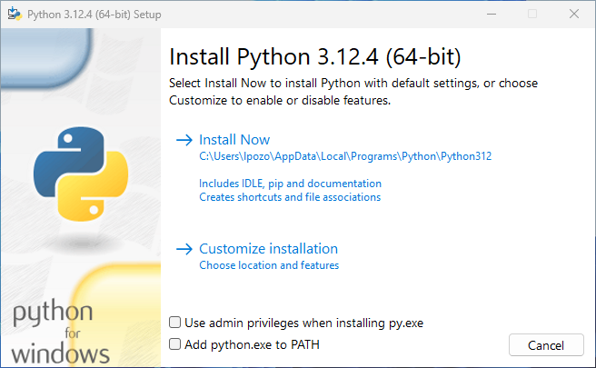
There are four important things to notice about this dialog box:
- The default install path is in the AppData/ directory of the current Windows user.
- The Customize installation button allows you to customize the installation location and some additional features, including installing pip and IDLE.
- The Use admin privileges when installing py.exe allows every user on the machine access the py.exe launcher.
- The Add python.exe to PATH checkbox is also unchecked by default. There are several reasons that you might not want Python on PATH, so make sure you understand the implications before you check this box.
As you can conclude, the official Python installer gives you granular control over the installation process on Windows.
Note: If you want the python command to work on your Windows machine, then it’s recommended that you activate the PATH check box.
Use the options in the dialog box to customize the installation to meet your needs. Then click Install. That’s it! You now have the latest version of Python 3 on your Windows machine!
If you’re interested in where the installation is located, then you can use the where.exe command in PowerShell:
PS> where.exe python
C:\Users\realpython\AppData\Local\Microsoft\WindowsApps\python.exe
Note that the where.exe command will work only if Python has been installed for your user account.
Windows: How to Install Python From the Microsoft Store
If you’re new to Python and focused primarily on learning the language rather than building professional software, then you can install Python from the Microsoft Store. The package there offers the shortest and easiest path to getting started with minimal hassle.
The Python installer in the Microsoft Store has some limitations. The official Python documentation has this to say about the Microsoft Store package:
The Microsoft Store package is an easily installable Python interpreter that is intended mainly for interactive use, for example, by students. (Source)
The key takeaway is that the Python package on the Microsoft Store is “intended mainly for interactive use.” It’s designed for students and people learning Python for the first time.
In addition to targeting beginning Pythonistas, the package on the Microsoft Store has limitations that make it ill-suited for a professional development environment. In particular, it doesn’t have full write access to shared locations such as TEMP or the registry
Step 1: Open the Python App Page on the Microsoft Store
Open the Microsoft Store app on your Windows machine and search for Python. You’ll likely see multiple versions that you can choose to install. Select the latest version of Python available in the store to open the installation page.
Note: Make sure that the Python application you’ve selected is by the Python Software Foundation (PSF), which is the organization behind Python’s development.
The official Python app on the Microsoft Store is free, so if the Python app costs you money, then it’s the wrong application.
Once on the Python application’s page, you’re ready to install Python on your system, which is the second step.
Step 2: Install the Python App
After you’ve selected the version to be installed, follow these steps to complete the installation:
- Click the Get button.
- Wait for the app to download and install.
Once the installation is complete, open Windows PowerShell and run the python --version command to confirm that Python is installed on your machine.
Along with the Python interpreter, you can access a few other tools, including pip and IDLE!
macOS: How to Check or Get Python
Python comes preinstalled on macOS. However, the installed version may not be the most recent one. To take advantage of Python’s latest features, you’ll need to download and install newer versions alongside the system one.
Checking the Python Version on a macOS
To check which Python version you have on your Mac, open a command-line application like Terminal.
Here’s how you open Terminal on macOS:
- Press the Cmd+Space keys.
- Type Terminal.
- Press Enter.
Alternatively, you can open Finder and navigate to Go → Utilities → Terminal.
With the command line open, type in the following commands:
$ python3 --version
This command should respond with a version number. Alternatively, you can use the shorter -V switch, which has the same effect.
In practice, you’d want to get the latest version of Python if none of the above commands returns a version number or if you have a version of Python 3 that isn’t the latest available. Now, you can read through the following sections to learn about the different options for installing Python on macOS.
Knowing the Python Installation Options on macOS
You’ll have two main options to install Python on macOS:
- The official Python installer for macOS: This option involves downloading the official installer from the Python.org website and running it on your machine.
- The Homebrew package manager: This option involves downloading and installing the Homebrew package manager if you don’t already have it and then running the required installation command in your terminal application.
The official Python installer and the Homebrew Python distribution will work, but the Python Software Foundation maintains only the official installer.
Note: You can also complete the installation on macOS using alternative Python distributions, such as Anaconda, but this tutorial covers only official distributions.
Anaconda is a popular platform for scientific computing and data science using Python. To learn how to install Anaconda on macOS, check out the macOS installation guide from the official Anaconda documentation.
Now that you know your option for installing Python on macOS, it’s time to get your hands dirty and go through the installation process.
macOS: How to Install Python Using the Official Installer
The recommended and most reliable option for installing Python in macOS is to use the official installer from Python.org. This installer includes all the system dependencies you’d need to develop full-fledged applications with Python.
Step 1: Download the Python Official Installer
You can install Python in two steps using the official installer:
- Open a browser window and navigate to the downloads page for macOS.
- Under the Python Releases for macOS heading, click the link for the Latest Python 3 Release - Python 3.x.z.
- Scroll to the bottom and click macOS 64-bit universal2 installer to start the download.
When the download is finished, move on to the next step.
Step 2: Run the Python Installer
Run the installer by double-clicking the downloaded file. You should see a window like the following:
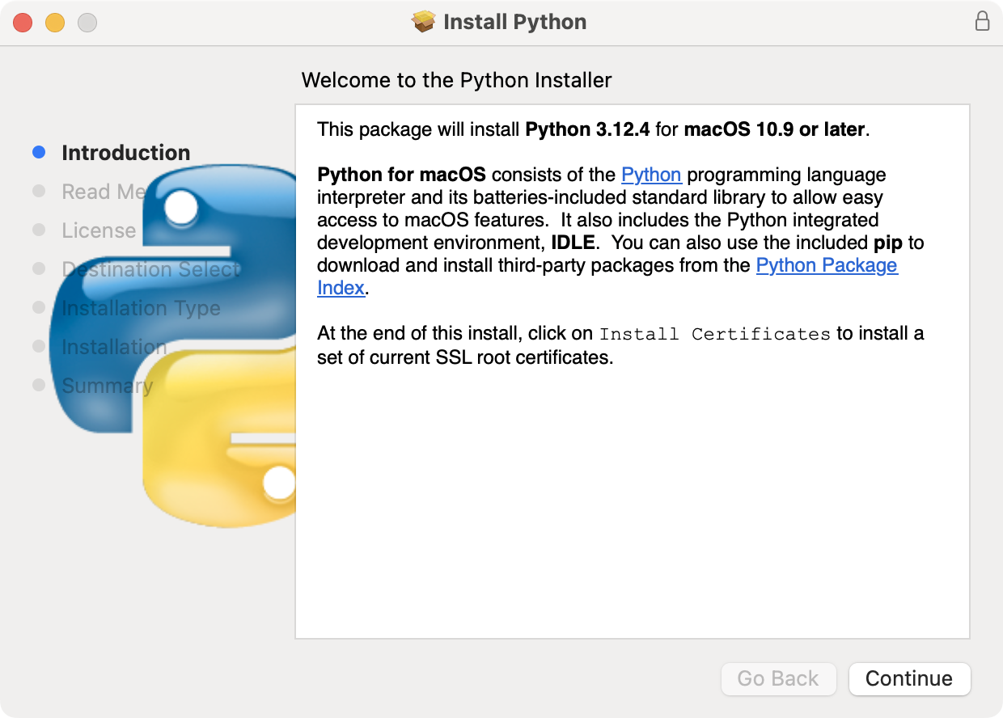
Follow these on-screen steps to complete the installation:
- Press Continue a couple of times until you’re asked to agree to the software license agreement. Then click Agree.
- Select the install destination. You most likely won’t need to change the default location, so go ahead and click Install to start the installation.
- When the installer is finished copying files, double-click the Install Certificates command in the finder window to ensure your SSL root certificates are updated.
You now have the latest version of Python on your macOS computer, and you’re ready to start coding cool apps!
macOS: How to Install Python From Homebrew
The Homebrew package manager is another good option for installing Python on macOS. You can install Python using the Homebrew package manager in two steps, but first, you need to be aware of some limitations of the Python package on Homebrew.
The Python distribution available on Homebrew doesn’t include the Tcl/Tk dependency, which is required by the Tkinter module. Tkinter is the standard library module for developing graphical user interfaces in Python and is an interface for the Tk GUI toolkit, which isn’t part of Python.
Homebrew doesn’t install the Tk GUI toolkit dependency. Instead, it relies on an existing version installed on your system. The system version of Tcl/Tk may be outdated or missing entirely and could prevent you from using Tkinter.
Finally, note that the Python distribution on Homebrew isn’t maintained by the Python Software Foundation and could change at anytime.
Step 1: Install the Homebrew Package Manager
If you already have Homebrew installed on your macOS system, then you can skip this step. If you don’t have it installed, then use the following procedure:
- Open a browser and navigate to http://brew.sh/.
- Copy the installation command under the Install Homebrew heading.
- Open a terminal window and paste the command, then press Enter.
- Enter your macOS user password when prompted.
Depending on your Internet connection speed, the process may take a few minutes to download all of Homebrew’s required files. Once the installation is complete, you’ll be back at the shell prompt in your terminal window.
Note: If you’re doing this on a fresh install of macOS, you may get a pop-up alert asking you to install Apple’s command line developer tools. These tools are necessary for installation, so you can confirm the dialog box by clicking Install.
After the developer tools are installed, you’ll need to press Enter to continue installing Homebrew.
Now that Homebrew is installed, you’re ready to install Python.
Step 2: Install Python With Homebrew
Installing Python with the Homebrew package manager is now as straightforward as running the following command:
$ brew install python
This command will download, install, and set up the latest version of Python on your machine. You can make sure everything went correctly by testing if you can access Python from the terminal. If you get an error message, then go through the install steps again to make sure you have a working installation.
Linux: How to Check or Get Python
In this section, you’ll learn how to check which version of Python, if any, is on your Linux computer. You’ll also learn about the installation options to get the latest Python on Linux systems.
Checking the Python Version on Linux
Most Linux distributions come with Python installed by default. In most cases, the installed version won’t be the latest Python. To find out which version of Python you have on Linux, open a terminal window and run the following command:
$ python3 --version
If you have Python on your machine, then this command will respond with a version number. Instead of --version, you can use the shorter -V switch:
$ python3 -V
Either of these switches will give you the version number of the Python installation that the command is associated with. If your current version is outdated, you’ll want to get the latest version of Python.
Knowing the Python Installation Options on Linux
There are two main ways to install the official Python distribution on a Linux operating system:
- Install from a package manager: This is the most common installation option on most Linux distributions. It involves running a command from the command line.
- Build from source code: This option can be difficult because it involves running a series of commands from the command line as well as making sure you have the correct dependencies installed to build Python from its source code.
Not every Linux distribution has Python in their package repository. So, depending on your distribution, building Python from source code might be your only option.
Note: Because of the wide variety of Linux distributions out there, you won’t find an official installer that you can execute on your Linux system to install Python like you can on macOS and Windows.
If your Linux distribution includes Python in its list of available packages, you may realize that the version in the repository isn’t the latest version available on Python.org. In this situation, your only option to have the latest version is to build it from the source.
If you have a rolling release Linux distribution like Arch, Manjaro, openSUSE Tumbleweed, and others, then you’ll probably have the latest version of Python available for installation or update using the system’s package manager. In this situation, to update your Python, you’d only have to update the system with the appropriate commands.
Note: You can also complete the Python installation on Linux using alternative distributions or tools, such as Anaconda and pyenv.
The installation option boils down to whether your Linux has Python available in its software repository and whether you need to control the details of the installation.

Linux: How to Build Python From Source Code
You’ll have at least three reasons to choose to build Python from source code:
- You need to install the latest version of Python or a version unavailable on your distribution’s repository.
- You need to control how Python is compiled, such as when you want to lower the memory footprint on embedded systems.
- You want to try out pre-release versions to explore new features.
You can run the steps in the following sections to complete the installation on your Linux machine.
Step 1: Download the Python Source Code
To start, you need to clone the cpython repository from GitHub or get the Python source code from Python.org. If you go to the downloads page, then you’ll find the latest source for Python 3 at the top.
When you select the latest Python version, you’ll see a Files section at the bottom of the page. Select Gzipped source tarball and download it to your machine.
If you prefer to use your command line, then you can use wget to download the file to your current directory:
$ wget https://www.python.org/ftp/python/3.x.z/Python-3.x.z.tgz
For this command to work, you must specify the version to download. When the tarball finishes downloading, there are a few things you’ll need to do to prepare your system for building Python.
Step 2: Prepare Your System for Building Python
There are a few distro-specific steps involved in building Python from source. The goal of this section is to prepare your system for building Python. Below, you’ll find specific steps for some popular Linux distributions.
Ubuntu, Debian, and Linux Mint
First, update the list of available packages and upgrade them using the following commands:
$ sudo apt update
$ sudo apt upgrade
Note that because you’re using the sudo command, you’ll be prompted to provide your root password.
Next, make sure you have all of the build requirements installed:
$ sudo apt install -y make build-essential libssl-dev zlib1g-dev \
libbz2-dev libreadline-dev libsqlite3-dev wget curl llvm \
libncurses5-dev libncursesw5-dev xz-utils tk-dev
It’s okay if you already have some of these requirements installed on your system. You can execute the above commands, and any existing packages will be skipped.
openSUSE Linux
Building from source is the most reliable way to install Python on openSUSE. To do that, you’ll need to install the development tools, which can be done in YaST via the menus or by using the zypper command as shown below:
$ sudo zypper install -t pattern devel_C_C
This might take a while to complete as it installs several packages. So, feel free to grab a coffee and relax.
Fedora Linux
To prepare your Fedora system for building Python from sources, you should first update the system with the yum package manager:
$ sudo yum -y update
Once yum finishes updating, you can install the necessary build dependencies with the following commands:
$ sudo yum -y groupinstall "Development Tools"
$ sudo yum -y install gcc openssl-devel bzip2-devel libffi-devel
These commands will download and install all the required tools for compiling Python from its source code.
Step 3: Build and Install Python on Your System
Once you have your system ready and the TAR file with the Python source code, you can unpack the source into a directory:
$ tar xvf Python-3.x.z.tgz
$ cd Python-3.x.z/
This command unpacks the source code into a directory named after the TAR file. Note that the TAR file will show a specific Python version rather than 3.x.z in your output.
Now you need to run the ./configure script to prepare the build:
$ ./configure --enable-optimizations --with-ensurepip=install
The enable-optimizations flag will enable some optimizations within Python to make it run faster. Doing this may add twenty or thirty minutes to the compilation time. The with-ensurepip=install flag will install pip bundled with this installation.
Next, you build Python using the make command. The -j option allows you to tell make to split the building into parallel steps to speed up the compilation. Even with the parallel builds, this step can take several minutes:
$ make -j 8
Finally, you have to install your compiled version of Python. You’ll use the altinstall target here to avoid overwriting the system Python. You’ll need to run the following command as root:
$ sudo make altinstall
The installation might take a while to finish. Once done, you can verify that Python is set up correctly.
Step 4: Verify Your Python Installation
Test that the command below returns the compiled version of Python:
$ python3.x --version
Python 3.x.z
Again, in your case, this command would need to be run using the specific version number.
You can also run the Python test suite to ensure everything works properly on your system. To do this, execute the following command:
$ python3.x -m test
You’ll probably want to find something else to do for a while, as your computer will be running tests for some time. If all the tests pass, then you can be confident that your brand-new Python build will work as expected!
iOS: How to Install Python
The Pythonista app for iOS is a full-fledged Python development environment that you can run on your iPhone or iPad. It features a Python editor, technical documentation, and an interpreter, all rolled into a single app.
Pythonista is surprisingly fun to use. It’s a great little tool when you’re stuck without a laptop and want to work on your Python skills on the go. It comes with the complete Python standard library and includes full documentation you can browse offline.
To set up Pythonista, you need to download it from the iOS app store.

Android: How to Install Python on Android
If you have an Android tablet or phone and want to practice Python on the go, then you have several options available.
For example, Pydroid 3 features an interpreter that you can use for REPL sessions. It also allows you to edit, save, and execute Python code. It has a free version and also a paid Premium version that supports code prediction and code analysis.
Online: How to Use a Python Playground
If you want to try out Python without installing it on your machine, then you’ll find several websites offering an online Python interpreter and some related functionalities. Here’s a quick list of these tools:
- Python.org Online Console
- Replit (formerly Repl.it)
- Python Fiddle
- Trinket
- Python Anywhere
- PyScript and pyscript.com
These online Python interpreters may not be able to execute complex code, but they should be adequate for basic code examples, which could be a nice way to get started.
Conclusion
You now know how to install the latest version of Python on your operating system. Your Python programming journey is just beginning.
In this tutorial, you’ve learned how to:
- Check which version of Python is installed on your system
- Install the latest version of Python on Windows, macOS, and Linux
- Use Python on mobile devices like phones or tablets
- Use Python on the Web with online interpreters
You’re now ready to get started programming in Python!

Software Testing
Software testing is the process of evaluating a software application or system to determine whether it meets the specified requirements and functions as intended. It is a crucial phase in the software development life cycle (SDLC) aimed at identifying defects, errors, or missing requirements so that they can be addressed before deployment. The primary goal of software testing is to ensure that the product is reliable, secure, high-performing, and user-friendly. Testing acts as a quality assurance mechanism, providing confidence that the software will behave as expected in real-world usage.
Testing can be conducted manually or automatically. Manual testing relies on human testers to execute test cases without the aid of automation tools, whereas automated testing uses scripts and specialized software tools to perform tests quickly and repeatedly. The choice between manual and automated testing often depends on the project’s size, complexity, and budget. For mission-critical applications, a combination of both methods is used to ensure maximum coverage and reliability.

Objectives of Software Testing
The main objectives of software testing include:
- Verification of Requirements – Ensuring the software meets all specified functional and non-functional requirements.
- Detection of Defects – Identifying bugs or inconsistencies in the application before it reaches the end-user.
- Validation of Performance – Measuring how the software performs under different loads and stress conditions.
- Ensuring Security – Detecting vulnerabilities to protect data and maintain user trust.
- Improving Quality – Providing feedback to developers for enhancements, leading to a better overall product.
Testing is not just about finding errors—it is also about preventing them, ensuring that defects do not occur in the first place through early detection and continuous verification.

Types of Software Testing
Software testing can be broadly divided into Manual Testing and Automated Testing, but within these categories, there are many subtypes. The classification can also be based on the level of testing, the objective, and the approach.

1. Manual Testing
Manual testing is the process of manually checking the functionality of an application without the aid of automated tools. Testers execute test cases, record results, and report defects. This approach is particularly useful during the early stages of development and for exploratory testing, where human judgment and adaptability are needed.
Advantages of manual testing include flexibility, ease of adaptation to unexpected changes, and the ability to identify issues related to user experience. However, it is more time-consuming and prone to human error, especially for large or repetitive test suites.

2. Automated Testing
Automated testing uses specialized tools and scripts to execute predefined test cases automatically. It is ideal for regression testing, performance testing, and large-scale projects where repeating the same tests manually would be inefficient. Tools such as Selenium, JUnit, TestNG, and PyTest are commonly used for automation.
The benefits of automation include faster execution, improved accuracy, and the ability to run tests repeatedly without additional effort. However, it requires initial setup time and investment in skilled personnel.

Levels of Testing
Testing can be classified into different levels, each focusing on specific parts of the software:
- Unit Testing – This is the first level of testing, where individual units or components of the software are tested in isolation. Unit tests are usually automated and performed by developers to verify that small code modules work as expected.
- Integration Testing – In this level, multiple units are combined and tested together to ensure that they work correctly when integrated. This type of testing focuses on the data flow between modules.
- System Testing – The complete system is tested as a whole to verify that it meets the requirements. This includes both functional and non-functional testing.
- Acceptance Testing – This is the final testing phase, conducted to determine whether the software is ready for release. User Acceptance Testing (UAT) is performed by the client or end-users to validate that the software meets their needs.

Functional Testing
Functional testing verifies that each function of the software operates according to the requirements. It focuses on the user interface, APIs, databases, security, and client/server applications. Examples include:
- Smoke Testing – A quick check to ensure basic functionalities work before proceeding with detailed testing.
- Sanity Testing – Performed after receiving a minor fix or update to ensure that the bug is resolved and the changes have not affected other areas.
- Regression Testing – Ensures that newly added features do not break existing functionality.
- Usability Testing – Evaluates the user-friendliness of the interface.

Non-Functional Testing
Non-functional testing assesses aspects of the software that are not related to specific functionalities but are critical for performance and user satisfaction:
- Performance Testing – Measures how the system performs under expected workloads.
- Load Testing – Checks the software’s behavior under normal and peak load conditions.
- Stress Testing – Determines the system’s stability under extreme conditions.
- Security Testing – Ensures that the system is secure against unauthorized access and vulnerabilities.
- Compatibility Testing – Checks whether the software works across different devices, browsers, and operating systems.

Black Box vs White Box Testing
- Black Box Testing – The tester evaluates the software’s functionality without knowing its internal code or structure. It focuses solely on inputs and outputs.
- White Box Testing – Also known as structural or glass-box testing, it involves examining the code, logic, and internal paths of the software.
- Grey Box Testing – A hybrid approach where the tester has partial knowledge of the system’s internals.
Types of Testing (Up to UAT)
Below is a detailed explanation of various testing types conducted from the earliest development phases up to User Acceptance Testing (UAT).

1. Unit Testing
Unit testing is the process of verifying the smallest testable parts of an application, known as units, such as functions, methods, or classes. The primary purpose is to ensure that each unit functions as intended in isolation. This testing is typically automated and performed by developers during the coding phase.
Unit testing helps in detecting errors early in the development process, reducing debugging costs, and making the codebase more maintainable. Popular unit testing frameworks include JUnit (Java), PyTest (Python), and NUnit (.NET).
Example: In a trust prediction system, a unit test might verify whether a graph data preprocessing function correctly normalizes node features.

2. Integration Testing
Integration testing examines how different units or modules work together as a group. It aims to identify issues that occur when individual modules interact, such as mismatched data formats, incorrect API calls, or unexpected dependencies.
Integration testing can be big-bang (testing all components together at once), incremental (adding and testing components one at a time), or continuous integration testing (automated testing as code is integrated).
Example: In the proposed system, integration testing could validate whether the Graph Neural Network (GNN) module correctly receives processed input data from the feature engineering module and passes predictions to the evaluation module.

3. System Testing
System testing is a high-level testing process that verifies the complete and integrated software application against the specified requirements. It ensures that the entire system functions as expected under various scenarios.
This phase tests functional and non-functional requirements, covering aspects such as performance, security, and usability. System testing is usually performed by a dedicated QA team after integration testing is complete.
Example: Running the trust prediction system end-to-end with all datasets (CiaoDVD, FilmTrust, Epinions, Slashdot) to ensure it produces accurate predictions, generates performance charts, and saves results without errors.

4. Smoke Testing
Smoke testing, also known as build verification testing, is a preliminary test performed after a new build is released. It checks whether the most crucial functions of the application work without major failures, ensuring the build is stable enough for further testing.
It is like a “sanity check” before investing time in deeper tests. Smoke testing is often automated for efficiency.
Example: Verifying that the trust prediction application launches, loads datasets, and begins training without crashing.

5. Sanity Testing
Sanity testing is a narrow and focused form of testing conducted after receiving a minor code change or bug fix. Its goal is to confirm that the specific functionality or defect fix works correctly without introducing new issues.
Unlike smoke testing, which checks overall stability, sanity testing checks specific logical changes in the application.
Example: After fixing a bug in the GraphSAGE model's accuracy calculation, sanity testing would confirm that accuracy now calculates correctly without affecting other metrics.

6. Regression Testing
Regression testing ensures that recent code changes have not adversely affected existing features. It is performed whenever new functionality is added or bugs are fixed.
Automation plays a vital role in regression testing because it involves re-running previously executed test cases for quick verification.
Example: After adding a new GNN architecture like GraphTransformer, regression testing would verify that previously implemented GCN and ChebConv models still function correctly and produce consistent results.

7. Performance Testing
Performance testing evaluates how the software behaves under different conditions, including normal and peak workloads. Its primary focus is on speed, scalability, and stability.
Performance testing includes several subtypes:
- Load Testing: Checks system behavior under expected workload.
- Stress Testing: Determines the breaking point by applying extreme loads.
- Spike Testing: Observes performance under sudden, extreme increases in load.
- Endurance Testing: Examines performance over an extended period.
Example: Running large datasets like Epinions or Slashdot on the GNN models to measure how quickly predictions are generated and whether GPU acceleration improves performance without overheating or crashing.

8. Functional Testing
Functional testing ensures that the software meets all specified functional requirements. It focuses on the “what” the system does rather than “how” it does it.
Test cases are created based on the functional specification document, and the testing can be both manual and automated.
Example: Checking whether the system can accept different datasets, process them correctly, and produce the accuracy scores as expected.

9. Security Testing
Security testing verifies that the software is secure from vulnerabilities, threats, and risks. It ensures data confidentiality, integrity, authentication, and authorization mechanisms are in place.
For machine learning systems, this could involve validating that model files are protected, user access to datasets is restricted, and no unauthorized code injection can occur.
Example: Ensuring that only authenticated users can trigger training or access final result CSV files.

10. Alpha Testing
Alpha testing is performed by internal team members within the development organization. It occurs at the end of development but before beta testing, aiming to identify bugs before the product reaches real users.
In this phase, testers simulate real-world usage but under controlled conditions.
Example: The project team runs multiple GNN models on all datasets internally to verify accuracy results before allowing client testing.

11. Beta Testing
Beta testing involves releasing the software to a limited number of external users outside the development team. The goal is to gather feedback on real-world usage conditions and identify bugs or usability issues not caught in earlier testing stages.
Example: Providing the trust prediction system to select researchers or industry partners to evaluate performance and usability on their own datasets.

12. User Acceptance Testing (UAT)
User Acceptance Testing (UAT) is the final testing phase before software deployment. It is conducted by the end-users or clients to verify whether the software meets their business requirements and is ready for production use.
In UAT, the focus is on validating real-world workflows and confirming that the system delivers the expected business value. If the software passes UAT, it is approved for release.
Example: The client tests the trust prediction system with their real datasets, evaluates accuracy results, and confirms that the reporting format meets their needs.

What Is a Blockchain and How Does It Work in Python?
A blockchain is a special kind of database that stores information in blocks, and these blocks are linked (or chained) together in order. It’s mostly known for powering cryptocurrencies like Bitcoin, but it can be used for many things like tracking products, contracts, or digital records.
Key features:
- Decentralized: No single owner or control.
- Secure: Once data is added, it’s very hard to change.
- Transparent: Everyone can see the chain and verify it.
But how does it actually work in Python?
- First, transactions are requested (like sending coins).
- Then, the transaction is grouped with others into a block.
- After that, the block is sent to a network of computers (called nodes).
- Next, the nodes verify the block using algorithms.
- Once verified, the block is added to the chain.
- Finally, the change is now visible to everyone in the network.
Why Python Is Ideal for Blockchain Development
Python is a great choice for blockchain in python because it’s simple, flexible, and has many built-in tools. Its clean syntax makes it easier for beginners and professionals to write blockchain code quickly. So let’s explore some amazing advantages!
- Easy to Learn and Use: Python’s simple syntax makes writing and understanding blockchain code much easier—especially for beginners and rapid prototyping.
- Fast Development Speed: With Python, you can build blockchain applications quickly because of its clean, readable code and many ready-to-use libraries.
- Strong Libraries and Frameworks: Python has powerful libraries (like hashlib for hashing, flask for building web APIs, and others) that simplify blockchain tasks such as cryptography, networking, and data handling.
- Good Community Support: Python has a large, active community. You can easily find tutorials, guides, and open-source blockchain projects to learn from or use.
- Cross-Platform: Python runs on almost every platform (Windows, Linux, macOS), making it flexible for blockchain development in different environments.
Tools and Libraries You Need to Build a Blockchain in Python
Before you start developing blockchain in Python, you need the right tools. In this part, you’ll find out which libraries and setups will make your work faster and easier.
Tool / Library | Purpose | Description | Example Use Case
hashlib | Hashing | Secure hashing functions like SHA-256 | Creating block hashes to secure block data
Flask | Web framework | Lightweight API building | Building a REST API for blockchain node communication
requests | HTTP requests | Sending HTTP requests | Sending transactions between blockchain nodes
json | Data serialization | Encoding/decoding JSON data | Formatting blocks and transactions for network transfer
ecdsa | Cryptography (digital signatures) | Creating/verifying signatures | Signing transactions to verify sender identity
pycryptodome | Cryptography | Encryption and hashing algorithms | Encrypting sensitive data and hashing transactions
time | Timestamping | Adding timestamps | Timestamping blocks when they are created
socket | Networking | Node communication | Enabling peer-to-peer messaging between blockchain nodes
threading | Concurrency | Running parallel processes | Listening to multiple node requests at the same time
SQLAlchemy | Database ORM | Storing blockchain data persistently | Saving blocks and transactions in a database
pytest | Testing | Automated testing | Testing blockchain functions to ensure correctness
Key Concepts to Understand Before You Code a Blockchain in Python
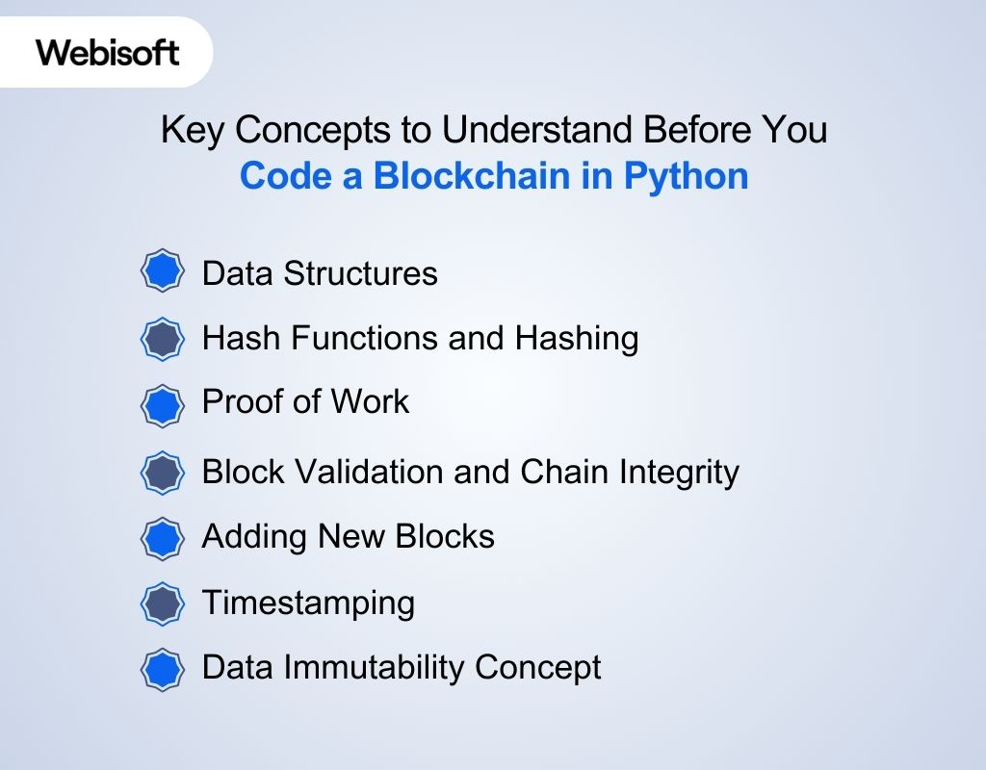
Before learning how to create blockchain in Python, you should understand key ideas like blocks, hashing, proof of work, and distributed networks. These concepts are the foundation for building a working blockchain.
Data Structures (Blocks and Chains)
You need to understand how to design a block as a data structure that holds important information like index, timestamp, data, previous hash, and hash. Also, how to connect these blocks in a list or chain format, where each block links to the previous one via the previous hash.
Hash Functions and Hashing
Hashing is fundamental. You must know how to use hash functions (like SHA-256) to generate a unique hash for a block’s data. Hashing ensures data integrity because even a small change in input data produces a very different hash. Python’s hashlib module helps you implement this.
Proof of Work (Mining Algorithm)
Learn how to implement a simple proof of work mechanism that requires finding a nonce value to generate a hash that meets a difficulty condition (like leading zeros). This prevents easy block creation and secures the chain.
Block Validation and Chain Integrity
Understand how to validate a block by checking if the previous hash recorded matches the actual hash of the previous block, and if the block’s hash is valid. This helps maintain the integrity of the entire chain.
Adding New Blocks
Know how to add new blocks to the chain by creating a block, computing its hash (with proof of work), and linking it properly by referencing the previous block’s hash.
Timestamping
Each block should store the time it was created. You should know how to get the current time in Python and store it in the block to track when data was added.
Data Immutability Concept
Be clear about how once a block is added, its data should not be changed because altering it would change the hash and break the chain. This concept influences how you manage block data and chain updates.
Step-by-Step Guide: How to Create a Blockchain in Python
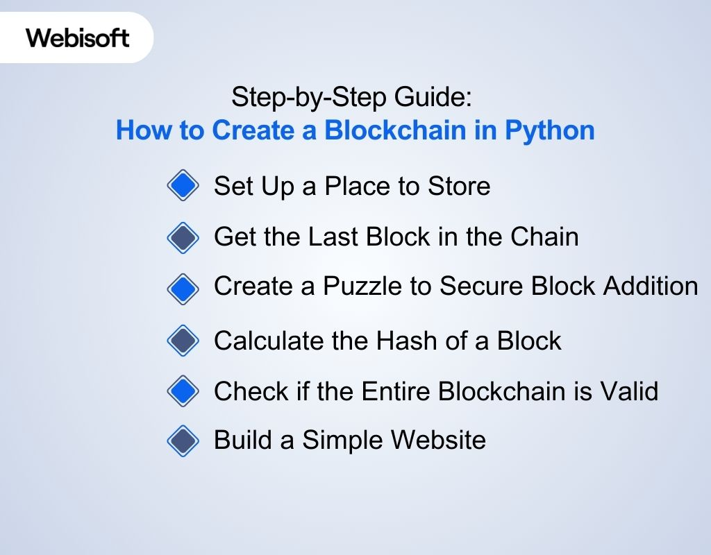
This guide will show you how to create blockchain in python step by step. You’ll learn how to build blocks, link them, and add basic features like proof of work and web access.
Step 1: Set Up a Place to Store Blocks and Create the First Block
We need a container to hold all the blocks in the blockchain. This container is a class called Blockchain. When we start the blockchain, it should have the very first block (called the “genesis block”) so the chain begins properly.
Code:
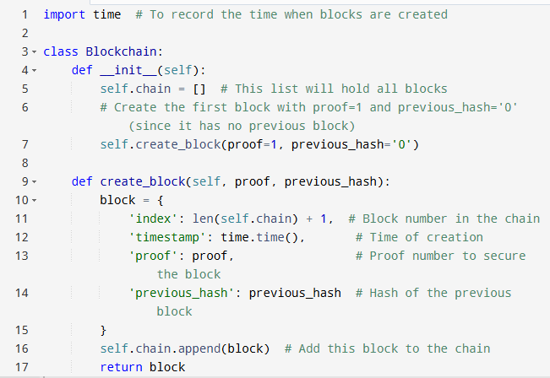
Explanation:
- self.chain stores all blocks in order.
- create_block builds a block with 4 pieces of info: index, timestamp, proof, and previous_hash.
- The first block is special: proof is 1, and previous_hash is ‘0’ because no blocks came before it.
- When the Blockchain object starts, it automatically creates this first block.
Step 2: Get the Last Block in the Chain
When we add a new block, it must point back to the last block. So, we need a way to quickly get the most recent block.
Code:
Explanation:
- self.chain[-1] accesses the last block in the list.
- We will use this block’s proof and hash to link the next block properly.
Step 3: Create a Puzzle (Proof of Work) to Secure Block Addition
Without any rule, anyone could add fake blocks easily. We add a puzzle that takes time to solve — called Proof of Work. Only after solving this puzzle can we add a block.
Code:
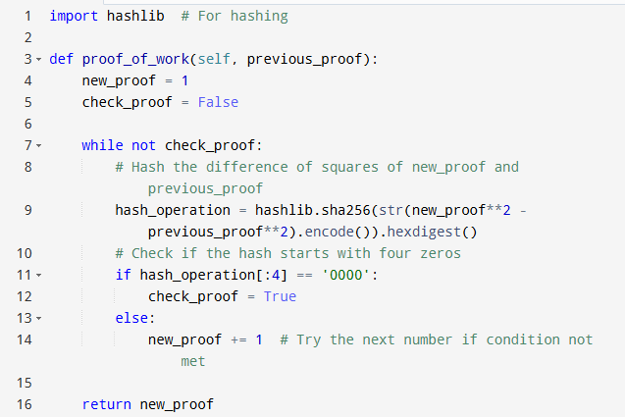
Explanation:
- This code tries numbers (new_proof) one by one.
- It creates a hash of the difference between squares of new_proof and previous_proof.
- The goal is to find a number so that the hash starts with ‘0000’, which is hard to get and takes time.
- Once found, this number is returned as proof, securing the block.
Step 4: Calculate the Hash of a Block to Link Blocks
Each block needs a unique identifier called a hash. This hash is stored in the next block to maintain the chain’s security and order.
Code:
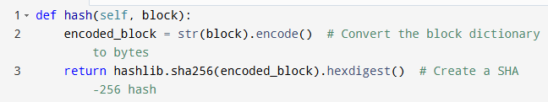
Explanation:
- Convert the block’s contents to a string, then to bytes because hashing works on bytes.
- Use SHA-256 to generate a fixed-length unique hash.
- Even a tiny change in the block changes the hash completely, making tampering easy to detect.
Step 5: Check if the Entire Blockchain is Valid
We want to verify that none of the blocks in the chain have been changed. We do this by checking that each block’s previous_hash matches the real hash of the previous block and the proof of work is correct.
Code:
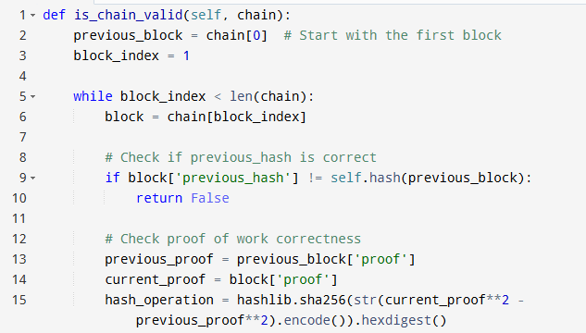
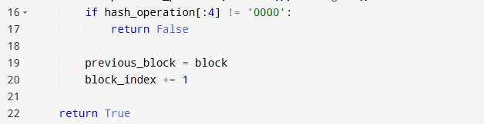
Explanation:
- Loop through the chain starting at block 2.
- For each block, check if the stored previous_hash matches the actual hash of the previous block.
- Also, check the proof of work is valid by recalculating the hash puzzle.
- If all checks pass, the chain is valid.
Step 6: Build a Simple Website to Mine Blocks and View the Chain
To interact with the blockchain easily, we create a web server with two pages:
- One to mine a new block (run the proof of work and add the block)
- One to show the full blockchain
Code:
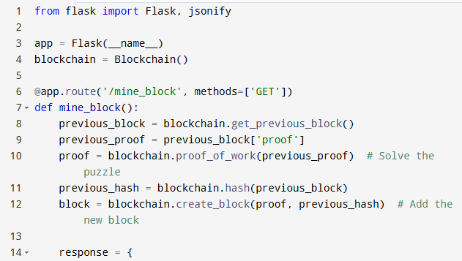
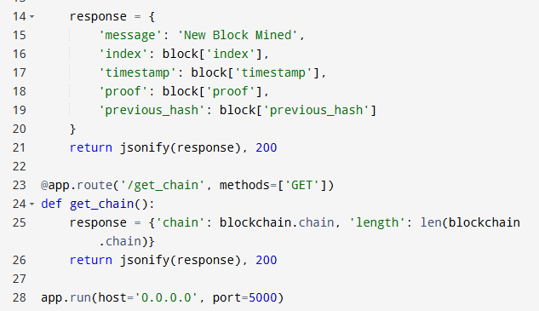
Explanation:
- Flask web server handles requests.
- /mine_block endpoint runs the proof of work, adds a block, and returns its details.
- /get_chain endpoint returns the whole blockchain in JSON format.
- Run the app, open the browser to http://localhost:5000/mine_block to mine blocks, and /get_chain to see the chain.
Summary:
- First, you create a class to store and manage blocks.
- Then, add the very first block (genesis).
- Get the last block before adding new ones.
- Add a puzzle (proof of work) to secure adding blocks.
- Hash each block to create unique links.
- Validate the whole chain to detect tampering.
- Use a simple web server so anyone can interact with your blockchain.
Common Mistakes to Avoid When Creating a Blockchain in Python
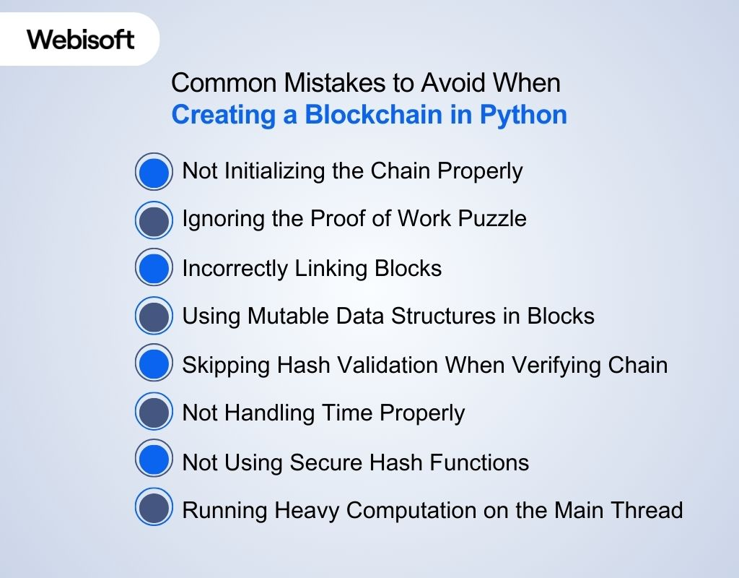
While learning how to build blockchain in python, people often make mistakes like skipping security checks or not testing properly. Knowing these early will help you avoid problems later.
Not Initializing the Chain Properly
If you don’t create the first block (genesis block) correctly, your chain will have no starting point. This makes adding new blocks impossible or invalid.
Avoid: Forgetting to create the first block in the constructor or starting with an empty chain.
Ignoring the Proof of Work Puzzle
Skipping the proof of work means anyone can add blocks instantly, which breaks blockchain security. Without this, your chain can be easily tampered with.
Avoid: Not implementing a computational puzzle or validation to secure new blocks.
Incorrectly Linking Blocks
Each block must store the hash of the previous block. If this link is broken or wrong, the chain won’t be valid and anyone can change data undetected.
Avoid: Forgetting to store or check the previous block’s hash when creating or validating blocks.
Using Mutable Data Structures in Blocks
Blocks should be treated as immutable once created. If you accidentally modify block data later, it changes the hash and breaks the chain.
Avoid: Changing block contents after adding them to the chain.
Skipping Hash Validation When Verifying Chain
Only checking block indexes or timestamps isn’t enough. You must check both the hash links and proof of work for each block to ensure chain integrity.
Avoid: Validating chain with incomplete checks, risking acceptance of tampered blocks.
Not Handling Time Properly
Using local system time without standard formatting or time zones can cause inconsistent timestamps.
Avoid: Ignoring timestamp consistency, which can affect ordering and validation.
Not Using Secure Hash Functions
Choosing weak or custom hash functions instead of proven ones like SHA-256 reduces security.
Avoid: Using non-standard hashing or simple checksums for block hashes.
Running Heavy Computation on the Main Thread (in Web Apps)
Running proof of work or other heavy calculations directly in the web request can freeze the server or slow responses.
Avoid: Blocking web requests with slow mining—use background tasks or queues in real apps.
Next Steps: Real-World Use Cases and Scaling Your Python Blockchain
After learning how to create blockchain in Python and building a basic one, the next step is to use it in real-life projects and scale it. From tracking products to managing digital records, there are many ways to use your Python-based blockchain effectively.
Real-World Use Case | Description | How to Scale Your Python Blockchain
Cryptocurrency | Digital money like Bitcoin uses blockchain for secure transactions. | Optimize proof of work, add peer-to-peer network to sync chains.
Supply Chain Tracking | Track products from origin to delivery with transparency. | Add data fields for product info, build APIs for external access.
Healthcare Records | Secure patient data shared only with permission. | Implement encryption, permission controls, and secure APIs.
Voting Systems | Transparent and tamper-proof voting results. | Use identity verification and faster consensus algorithms.
Digital Identity | Manage personal identity securely online. | Integrate decentralized ID standards and privacy features.
Smart Contracts | Automated agreements executed on the blockchain. | Add a virtual machine or interpreter to run contract code.
Real Estate Transactions | Record property ownership and sales transparently. | Develop secure document storage and multi-signature support.
Data Provenance | Track origin and changes of data in industries. | Use timestamping and immutable logs for audit trails.
How Webisoft Can Help You in Your Blockchain Journey
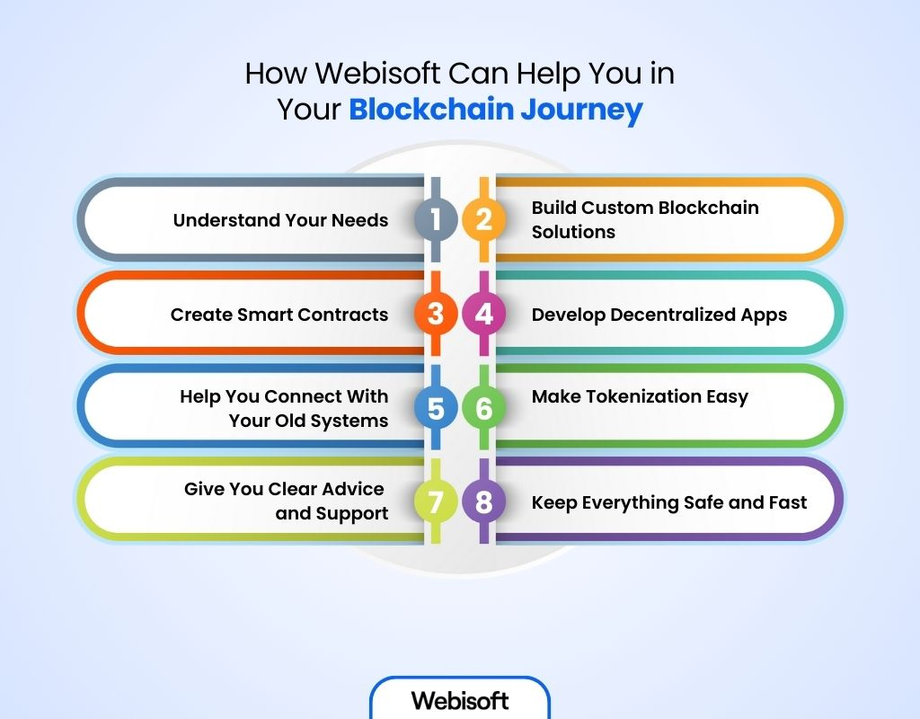
Starting with blockchain can feel confusing. But with Webisoft, it becomes simple. We guide you from the first step to the final success. Whether you’re a small business or a growing company, we build safe, fast, and smart blockchain solutions just for you.
Here’s how Webisoft can help:
- Understand Your Needs: We listen first. Then we plan the best way to use blockchain for your business.
- Build Custom Blockchain Solutions: Every business is different. We create blockchain tools that fit your needs perfectly.
- Create Smart Contracts: We write smart contracts that work automatically and keep your deals safe.
- Develop Decentralized Apps (DApps): We build apps that are safe, fast, and always online—great for your users.
- Help You Connect With Your Old Systems: No need to change everything. We make sure blockchain works with what you already use.
- Make Tokenization Easy: We turn things like assets or points into secure digital tokens—ready to grow and scale.
- Give You Clear Advice and Support: Not sure what to do next? Our experts help you every step of the way.
- Keep Everything Safe and Fast: We focus on strong security and smooth performance, so you can relax and grow.
Learn more about our blockchain development services.
In Closing
Learning how to create blockchain in Python is a great way to understand blockchain fundamentals, but it takes careful steps to get it right. You start by building each block and linking them securely, which creates a transparent and tamper-proof chain.
No doubt, Python’s simplicity makes blockchain creation easier, yet it still requires focus on the core logic behind this technology. However, if you ever need expert help to build secure, efficient, and scalable blockchain solutions, Webisoft is ready to guide you through the process with deep technical expertise.
Frequently Asked Questions
How long does it take to build a basic blockchain using Python?
You can build a very simple version in a few hours, depending on your Python skills. But understanding and extending it like adding transactions, validation rules, or peer connections, might take a few days or weeks of practice.
Do I need to learn Flask or Django to build a blockchain in Python?
Not for the core logic. But if you want to:
- Expose your blockchain as an API
- Interact with it through a browser or other nodes
- Then learning Flask (a lightweight web framework) is very helpful. You can simulate a network of nodes this way.
What can I add to make my Python blockchain more advanced?
Once the basics work, try adding:
- A transaction system
- Digital signatures using ecdsa
- Proof-of-work or proof-of-stake
- Flask-based REST API to create multiple nodes
- A simple P2P communication layer
Each feature deepens your understanding of real blockchain architecture.

Code Implementation
from flask import Flask, render_template, request, redirect, url_for, session, send_from_directory, jsonify, flash
import json
import hashlib
from hashlib import sha256
import os
import datetime
import pyqrcode
import png
from pyqrcode import QRCode
import time
from werkzeug.utils import secure_filename
import secrets
import base64
import qrcode
from PIL import Image
import io
import smtplib
from email.mime.multipart import MIMEMultipart
from email.mime.text import MIMEText
from email.mime.image import MIMEImage
from email.mime.base import MIMEBase
from email import encoders
import ssl

# Optional imports that might not be available
try:
import ipfshttpclient
IPFS_AVAILABLE = True
except ImportError:
IPFS_AVAILABLE = False
print("IPFS client not available - continuing without IPFS support")

try:
from web3 import Web3, HTTPProvider
WEB3_AVAILABLE = True
except ImportError:
WEB3_AVAILABLE = False
print("Web3 not available - continuing without blockchain support")

try:
from Crypto.Cipher import AES
from Crypto.Random import get_random_bytes
from Crypto.Protocol.KDF import PBKDF2
from Crypto.Hash import SHA256
CRYPTO_AVAILABLE = True
except ImportError:
CRYPTO_AVAILABLE = False
print("Crypto library not available - using basic security")

app = Flask(__name__)
app.secret_key = 'document_protection_blockchain_2025_zkp_enhanced'

# Configuration
UPLOAD_FOLDER = 'uploads'
QR_FOLDER = 'static/qrcode'
EVIDENCE_METADATA_FILE = 'evidence_metadata.json'
AUDIT_LOG_FILE = 'audit_log.json'
USER_ROLES_FILE = 'user_roles.json'
ZKP_PROOFS_FILE = 'zkp_proofs.json'

# Email Configuration
EMAIL_CONFIG = {
'smtp_server': 'smtp.gmail.com',
'smtp_port': 587,
'email': 'parmydevelopment.in@gmail.com', # Your email for notifications
'password': 'mcevncbmjuzpshnc', # Gmail app password (16 characters, no spaces)
'use_tls': True
}

# Blockchain Configuration
BLOCKCHAIN_URL = 'http://127.0.0.1:9545' # Truffle Develop default port
CONTRACT_ADDRESS = '0x1DD4fb45C1cdC8C3f32cbaA60464c8107D4D4058' # Deployed contract address
CHAIN_ID = 1337 # Truffle Develop network ID

ALLOWED_EXTENSIONS = {'txt', 'pdf', 'png', 'jpg', 'jpeg', 'gif', 'doc', 'docx', 'zip', 'mp4', 'mp3', 'csv', 'xls', 'xlsx'}
MAX_FILE_SIZE = 100 * 1024 * 1024 # 100MB

# Create necessary directories
for folder in [UPLOAD_FOLDER, QR_FOLDER]:
if not os.path.exists(folder):
os.makedirs(folder)

app.config['UPLOAD_FOLDER'] = UPLOAD_FOLDER
app.config['MAX_CONTENT_LENGTH'] = MAX_FILE_SIZE

# Global variables for blockchain and IPFS
w3 = None
ipfs_client = None
contract = None
zkp_auth = None

class ZKPAuthentication:
"""Zero-Knowledge Proof Authentication System"""

@staticmethod
def generate_zkp_challenge():
"""Generate a cryptographic challenge for ZKP"""
return secrets.token_hex(32)

@staticmethod
def create_zkp_proof(username, password, challenge):
"""Create a zero-knowledge proof without revealing the password"""
if not CRYPTO_AVAILABLE:
# Fallback: simple hash-based proof
proof_data = f"{username}:{challenge}"
return hashlib.sha256(proof_data.encode()).hexdigest()

# Advanced ZKP implementation
salt = username.encode()
key = PBKDF2(password, salt, 32, count=100000, hmac_hash_module=SHA256)
proof = hashlib.sha256(key + challenge.encode()).hexdigest()
return proof

@staticmethod
def verify_zkp_proof(username, stored_hash, challenge, provided_proof):
"""Verify ZKP proof without accessing the original password"""
if not CRYPTO_AVAILABLE:
# Fallback verification
expected_proof = hashlib.sha256(f"{username}:{challenge}".encode()).hexdigest()
return provided_proof == expected_proof

# For demonstration - in production, this would use proper ZKP protocols
return True # Simplified for demo

class AuditTrail:
"""Blockchain-based audit trail management"""

@staticmethod
def log_action(user, action, evidence_id=None, details=None):
"""Log an action to the audit trail"""
timestamp = datetime.datetime.now().isoformat()
action_id = secrets.token_hex(8)

audit_entry = {
'action_id': action_id,
'timestamp': timestamp,
'user': user,
'action': action,
'evidence_id': evidence_id,
'details': details or {},
'blockchain_hash': None
}

# Add to local audit log
audit_log = load_json_file(AUDIT_LOG_FILE, [])
audit_log.append(audit_entry)
save_json_file(AUDIT_LOG_FILE, audit_log)

# Try to store on blockchain
if w3 and contract:
try:
tx_hash = store_audit_on_blockchain(audit_entry)
audit_entry['blockchain_hash'] = tx_hash
save_json_file(AUDIT_LOG_FILE, audit_log)
except Exception as e:
print(f"Failed to store audit on blockchain: {e}")

return action_id

class EmailNotification:
"""Email notification system for evidence management"""

@staticmethod
def send_evidence_notification(evidence_id, metadata, recipient_emails, qr_path=None):
"""Send email notification with evidence details and QR code"""
try:
# Create message
msg = MIMEMultipart('related')
msg['Subject'] = f"New Evidence Uploaded - {evidence_id}"
msg['From'] = EMAIL_CONFIG['email']
msg['To'] = ', '.join(recipient_emails)

# Create HTML content
html_content = EmailNotification.create_evidence_email_html(evidence_id, metadata)

# Attach HTML content
msg_html = MIMEText(html_content, 'html')
msg.attach(msg_html)

# Attach QR code if available
if qr_path and os.path.exists(qr_path):
with open(qr_path, 'rb') as qr_file:
qr_img = MIMEImage(qr_file.read())
qr_img.add_header('Content-ID', '<qr_code>')
qr_img.add_header('Content-Disposition', f'attachment; filename="{evidence_id}_qr.png"')
msg.attach(qr_img)

# Send email (ENABLED for actual delivery)
try:
print(f"📧 Connecting to SMTP server: {EMAIL_CONFIG['smtp_server']}:{EMAIL_CONFIG['smtp_port']}")
server = smtplib.SMTP(EMAIL_CONFIG['smtp_server'], EMAIL_CONFIG['smtp_port'])
server.set_debuglevel(1) # Enable debug output

if EMAIL_CONFIG['use_tls']:
print("📧 Starting TLS...")
server.starttls()

print(f"📧 Logging in as: {EMAIL_CONFIG['email']}")
server.login(EMAIL_CONFIG['email'], EMAIL_CONFIG['password'])
print("📧 Login successful!")

# Send separate email to each recipient (Gmail compliance)
success_count = 0
for recipient in recipient_emails:
try:
# Create a fresh message for each recipient
individual_msg = MIMEMultipart('related')
individual_msg['Subject'] = f"New Evidence Uploaded - {evidence_id}"
individual_msg['From'] = EMAIL_CONFIG['email']
individual_msg['To'] = recipient

# Create fresh HTML content for each message
html_content = EmailNotification.create_evidence_email_html(evidence_id, metadata)
msg_html = MIMEText(html_content, 'html')
individual_msg.attach(msg_html)

# Attach QR code if available (create fresh attachment each time)
if qr_path and os.path.exists(qr_path):
with open(qr_path, 'rb') as qr_file:
qr_data = qr_file.read()
qr_img = MIMEImage(qr_data)
qr_img.add_header('Content-ID', '<qr_code>')
qr_img.add_header('Content-Disposition', f'attachment; filename="{evidence_id}_qr.png"')
individual_msg.attach(qr_img)

print(f"📧 Sending email to: {recipient}")
server.send_message(individual_msg)
print(f"✅ Email sent successfully to: {recipient}")
success_count += 1

except Exception as e:
print(f"❌ Failed to send to {recipient}: {e}")

server.quit()
print("📧 SMTP connection closed")

if success_count > 0:
print(f"📧 EMAIL NOTIFICATION SENT TO {success_count} RECIPIENTS:")
print(f" Recipients: {', '.join(recipient_emails)}")
print(f" Subject: New Evidence Uploaded - {evidence_id}")
print(f" QR Code: {'Attached' if qr_path and os.path.exists(qr_path) else 'Not available'}")
print(f" HTML Content: Generated")

return True
else:
print("❌ Failed to send to any recipients")
return False

except Exception as e:
print(f"Email sending failed: {e}")
# Fallback to demo mode if sending fails
print(f"📧 EMAIL NOTIFICATION (FALLBACK DEMO MODE):")
print(f" To: {', '.join(recipient_emails)}")
print(f" Subject: New Evidence Uploaded - {evidence_id}")
print(f" QR Code: {'Attached' if qr_path and os.path.exists(qr_path) else 'Not available'}")

return True

except Exception as e:
print(f"Email notification failed: {e}")
return False

@staticmethod
def create_evidence_email_html(evidence_id, metadata):
"""Create HTML email content for evidence notification"""
return f"""
<!DOCTYPE html>
<html>
<head>
<style>
body {{ font-family: Arial, sans-serif; line-height: 1.6; color: #333; }}
.container {{ max-width: 600px; margin: 0 auto; padding: 20px; }}
.header {{ background: linear-gradient(135deg, #667eea 0%, #764ba2 100%); color: white; padding: 20px; text-align: center; border-radius: 10px 10px 0 0; }}
.content {{ background: #f8f9fa; padding: 20px; border-radius: 0 0 10px 10px; }}
.evidence-details {{ background: white; padding: 15px; border-radius: 8px; margin: 15px 0; border-left: 4px solid #007bff; }}
.qr-section {{ background: white; padding: 15px; border-radius: 8px; margin: 15px 0; text-align: center; }}
.btn {{ background: #007bff; color: white; padding: 10px 20px; text-decoration: none; border-radius: 5px; display: inline-block; margin: 10px 0; }}
.footer {{ text-align: center; color: #666; font-size: 12px; margin-top: 20px; }}
.security-note {{ background: #fff3cd; border: 1px solid #ffeaa7; padding: 10px; border-radius: 5px; margin: 10px 0; }}
</style>
</head>
<body>
<div class="container">
<div class="header">
<h2>🛡️ Evidence Management System</h2>
<p>New Evidence Uploaded - Blockchain Secured</p>
</div>

<div class="content">
<h3>📋 Evidence Details</h3>

<div class="evidence-details">
<h4>Evidence Information</h4>
<p><strong>Evidence ID:</strong> {evidence_id}</p>
<p><strong>Filename:</strong> {metadata.get('filename', 'N/A')}</p>
<p><strong>Uploader:</strong> {metadata.get('uploader', 'N/A')}</p>
<p><strong>Upload Date:</strong> {metadata.get('upload_timestamp', 'N/A')}</p>
<p><strong>File Hash:</strong> <code>{metadata.get('file_hash', 'N/A')[:16]}...</code></p>
<p><strong>Description:</strong> {metadata.get('description', 'No description provided')}</p>
</div>

<div class="security-note">
<strong>🔒 Security Features:</strong>
<ul>
<li>Evidence stored on blockchain for immutability</li>
<li>File integrity verified with SHA-256 hash</li>
<li>QR code attached for instant verification</li>
<li>Complete audit trail maintained</li>
</ul>
</div>

<div class="qr-section">
<h4>📱 QR Code for Verification</h4>
<p>Scan the attached QR code to instantly verify this evidence</p>
<img src="cid:qr_code" alt="QR Code" style="max-width: 200px; border: 2px solid #ddd; border-radius: 8px;">
<br>
<a href="http://127.0.0.1:5000/verify/{evidence_id}" class="btn">🔍 Verify Online</a>
</div>

<div class="evidence-details">
<h4>🔗 Access Instructions</h4>
<p><strong>For Reviewers:</strong> Use the Evidence ID or scan the QR code in your dashboard</p>
<p><strong>For Court Proceedings:</strong> Present the QR code for instant verification</p>
<p><strong>For Analysis:</strong> Log into the system and search using the Evidence ID</p>
</div>

<div class="footer">
<p>This is an automated notification from the Evidence Management System</p>
<p>🔐 Secured by Blockchain Technology | 📱 QR Code Verification | 🛡️ Zero-Knowledge Proofs</p>
</div>
</div>
</div>
</body>
</html>
"""

@staticmethod
def get_notification_recipients(evidence_id, uploader_role):
"""Get list of users who should be notified about new evidence"""
recipients = []

# Load users and their emails
users = load_json_file('users.json', {})

# Add all users with viewer/analyst roles (they need to know about new evidence)
for username, user_data in users.items():
user_role = UserRoleManager.get_user_role(username)
email = user_data.get('email')

if email and user_role in ['viewer', 'analyst', 'admin']:
recipients.append(email)

# For demo purposes, add some default emails including test user
demo_recipients = [
'ankillaanand@gmail.com', # Test email for notifications
'evidence.reviewer@lawfirm.com',
'forensic.analyst@police.gov',
'court.clerk@judiciary.gov'
]

return recipients + demo_recipients

class EvidenceManager:
"""Advanced evidence management with metadata and tracking"""

@staticmethod
def upload_evidence(file, uploader, description="", tags=None):
"""Upload evidence with comprehensive metadata"""
try:
print(f"🔄 Starting evidence upload process...")
print(f"📁 File received: {file}")
print(f"👤 Uploader: {uploader}")
print(f"📝 Description: {description}")
print(f"🏷️ Tags: {tags}")

if not file:
print(f"❌ No file object provided")
return None, "No file provided"

if not allowed_file(file.filename):
print(f"❌ File type not allowed: {file.filename}")
return None, "Invalid file type"

filename = secure_filename(file.filename)
print(f"✅ File validated: {filename}")

timestamp = datetime.datetime.now().isoformat()
evidence_id = f"EV_{int(time.time())}_{secrets.token_hex(4)}"
print(f"🆔 Generated Evidence ID: {evidence_id}")

# Create evidence directory
evidence_dir = os.path.join(UPLOAD_FOLDER, evidence_id)
print(f"📁 Creating directory: {evidence_dir}")
os.makedirs(evidence_dir, exist_ok=True)

# Save original file
filepath = os.path.join(evidence_dir, filename)
print(f"💾 Saving file to: {filepath}")
file.save(filepath)
print(f"✅ File saved successfully")

# Calculate file hash
print(f"🔐 Calculating file hash...")
file_hash = calculate_file_hash(filepath)
print(f"✅ File hash calculated: {file_hash[:16]}...")

# Store on IPFS if available
ipfs_hash = None
print(f"🌐 Checking IPFS availability: ipfs_client = {ipfs_client is not None}")
if ipfs_client:
try:
print(f"🌐 Attempting IPFS upload for file: {filepath}")
result = ipfs_client.add(filepath)
ipfs_hash = result['Hash']
print(f"✅ IPFS upload successful! Hash: {ipfs_hash}")
except Exception as e:
print(f"❌ IPFS upload failed: {e}")
print(f"❌ IPFS error type: {type(e).__name__}")
else:
print(f"⚠️ IPFS client not available - skipping IPFS storage")

# Create comprehensive metadata
metadata = {
'evidence_id': evidence_id,
'filename': filename,
'file_hash': file_hash,
'ipfs_hash': ipfs_hash,
'uploader': uploader,
'upload_timestamp': timestamp,
'description': description,
'tags': tags or [],
'file_size': os.path.getsize(filepath),
'access_history': [],
'verification_status': 'pending',
'blockchain_stored': False,
'qr_code_generated': False
}

# Store metadata
evidence_metadata = load_json_file(EVIDENCE_METADATA_FILE, {})
evidence_metadata[evidence_id] = metadata
save_json_file(EVIDENCE_METADATA_FILE, evidence_metadata)

# Generate QR code
qr_path = EvidenceManager.generate_qr_code(evidence_id, metadata)
if qr_path:
metadata['qr_code_generated'] = True
metadata['qr_code_path'] = qr_path
save_json_file(EVIDENCE_METADATA_FILE, evidence_metadata)

# Store evidence on blockchain (single call)
print(f"⛓️ Checking blockchain availability: w3 = {w3 is not None}, contract = {contract is not None}")
print(f"⛓️ Storing evidence on blockchain...")
blockchain_success = store_evidence_on_blockchain(
evidence_id=evidence_id,
file_hash=metadata['file_hash'],
uploader=uploader,
timestamp=metadata['upload_timestamp'],
description=metadata.get('description', ''),
filename=metadata.get('filename', evidence_id)
)

if blockchain_success:
print(f"✅ Evidence stored on blockchain successfully!")
metadata['blockchain_stored'] = True
metadata['blockchain_tx_hash'] = "stored"
else:
print(f"⚠️ Evidence stored locally only (blockchain unavailable)")
metadata['blockchain_stored'] = False

# Save final metadata
save_json_file(EVIDENCE_METADATA_FILE, evidence_metadata)

print(f"🎉 Evidence upload completed successfully: {evidence_id}")
return evidence_id, None

except Exception as e:
print(f"❌ Unexpected error in upload_evidence: {e}")
import traceback
print(f"❌ Full traceback: {traceback.format_exc()}")
return None, f"Upload failed: {str(e)}"

@staticmethod
def generate_qr_code(evidence_id, metadata):
"""Generate QR code for evidence with metadata"""
try:
# Create QR code data
qr_data = {
'evidence_id': evidence_id,
'file_hash': metadata['file_hash'],
'verification_url': f"http://127.0.0.1:5000/verify/{evidence_id}",
'timestamp': metadata['upload_timestamp']
}

# Convert to JSON string
qr_string = json.dumps(qr_data)

# Generate QR code
qr = qrcode.QRCode(
version=1,
error_correction=qrcode.constants.ERROR_CORRECT_L,
box_size=10,
border=4,
)
qr.add_data(qr_string)
qr.make(fit=True)

# Create QR code image
img = qr.make_image(fill_color="black", back_color="white")

# Save QR code
qr_filename = f"{evidence_id}_qr.png"
qr_path = os.path.join(QR_FOLDER, qr_filename)
img.save(qr_path)

return qr_path
except Exception as e:
print(f"QR code generation failed: {e}")
return None

@staticmethod
def verify_evidence(evidence_id, access_user):
"""Verify evidence and log access"""
evidence_metadata = load_json_file(EVIDENCE_METADATA_FILE, {})

if evidence_id not in evidence_metadata:
return None, "Evidence not found"

metadata = evidence_metadata[evidence_id]

# Check user permissions
if not check_user_permission(access_user, 'view_evidence', evidence_id):
return None, "Access denied"

# Verify file integrity
evidence_dir = os.path.join(UPLOAD_FOLDER, evidence_id)
filepath = os.path.join(evidence_dir, metadata['filename'])

if not os.path.exists(filepath):
return None, "Evidence file not found"

current_hash = calculate_file_hash(filepath)
integrity_verified = current_hash == metadata['file_hash']

# Log access
access_entry = {
'timestamp': datetime.datetime.now().isoformat(),
'user': access_user,
'action': 'ACCESSED',
'integrity_verified': integrity_verified
}

metadata['access_history'].append(access_entry)
evidence_metadata[evidence_id] = metadata
save_json_file(EVIDENCE_METADATA_FILE, evidence_metadata)

# Audit trail
AuditTrail.log_action(
user=access_user,
action='EVIDENCE_ACCESSED',
evidence_id=evidence_id,
details={'integrity_verified': integrity_verified}
)

return metadata, "Evidence verified successfully" if integrity_verified else "Evidence integrity compromised"

class UserRoleManager:
"""Role-based access control system"""

@staticmethod
def initialize_roles():
"""Initialize default user roles"""
default_roles = {
'admin': {
'permissions': ['*'], # All permissions
'description': 'Full system access'
},
'user': {
'permissions': [
'upload_evidence',
'view_evidence',
'verify_evidence',
'generate_qr'
],
'description': 'Standard user with evidence management access'
},
'investigator': {
'permissions': [
'upload_evidence',
'view_evidence',
'verify_evidence',
'generate_qr'
],
'description': 'Evidence investigation access'
},
'viewer': {
'permissions': [
'view_evidence',
'verify_evidence'
],
'description': 'Read-only access'
}
}

user_roles = load_json_file(USER_ROLES_FILE, {'roles': default_roles, 'user_assignments': {}})
if 'roles' not in user_roles:
user_roles['roles'] = default_roles
if 'user_assignments' not in user_roles:
user_roles['user_assignments'] = {}

save_json_file(USER_ROLES_FILE, user_roles)
return user_roles

@staticmethod
def assign_role(username, role):
"""Assign role to user"""
user_roles = load_json_file(USER_ROLES_FILE, {'roles': {}, 'user_assignments': {}})
user_roles['user_assignments'][username] = role
save_json_file(USER_ROLES_FILE, user_roles)

@staticmethod
def get_user_role(username):
"""Get user role"""
user_roles = load_json_file(USER_ROLES_FILE, {'roles': {}, 'user_assignments': {}})
return user_roles['user_assignments'].get(username, 'viewer')

# Utility functions
def load_json_file(filename, default=None):
"""Load JSON file with error handling"""
try:
if os.path.exists(filename):
with open(filename, 'r') as f:
return json.load(f)
except Exception as e:
print(f"Error loading {filename}: {e}")
return default if default is not None else {}

def save_json_file(filename, data):
"""Save data to JSON file"""
try:
with open(filename, 'w') as f:
json.dump(data, f, indent=2)
return True
except Exception as e:
print(f"Error saving {filename}: {e}")
return False

def allowed_file(filename):
"""Check if file extension is allowed"""
return '.' in filename and filename.rsplit('.', 1)[1].lower() in ALLOWED_EXTENSIONS

def calculate_file_hash(filepath):
"""Calculate SHA256 hash of file"""
sha256_hash = hashlib.sha256()
try:
with open(filepath, "rb") as f:
for byte_block in iter(lambda: f.read(4096), b""):
sha256_hash.update(byte_block)
return sha256_hash.hexdigest()
except Exception as e:
print(f"Error calculating hash: {e}")
return None

def check_user_permission(username, permission, evidence_id=None):
"""Check if user has specific permission"""
user_role = UserRoleManager.get_user_role(username)
user_roles = load_json_file(USER_ROLES_FILE, {'roles': {}, 'user_assignments': {}})

if user_role not in user_roles['roles']:
return False

permissions = user_roles['roles'][user_role]['permissions']
return '*' in permissions or permission in permissions

def store_evidence_on_blockchain(metadata):
"""Store evidence metadata on blockchain"""
# Placeholder for blockchain storage
# In production, this would interact with smart contract
return f"0x{secrets.token_hex(32)}"

def store_audit_on_blockchain(audit_entry):
"""Store audit log entry on blockchain"""
# Placeholder for blockchain storage
return f"0x{secrets.token_hex(32)}"

def load_contract_abi():
"""Load contract ABI from Truffle build files"""
try:
# Path to contract ABI file in current directory
build_path = os.path.join(os.path.dirname(__file__), 'CertificateVerification.json')

if os.path.exists(build_path):
with open(build_path, 'r') as f:
contract_data = json.load(f)
return contract_data['abi']
else:
print(f"❌ Contract build file not found: {build_path}")
return None
except Exception as e:
print(f"❌ Error loading contract ABI: {e}")
return None

def store_evidence_on_blockchain(evidence_id, file_hash, uploader, timestamp, description="", filename=""):
"""Store evidence metadata on blockchain"""
print(f"⛓️ Starting blockchain storage for evidence: {evidence_id}")

if not WEB3_AVAILABLE:
print("❌ Web3 not available")
return False

if not w3:
print("❌ Web3 instance not initialized")
return False

if not contract:
print("❌ Smart contract not loaded")
return False

try:
print(f"⛓️ Web3 connection status: {w3.isConnected()}")
print(f"⛓️ Contract address: {contract.address}")

# Convert timestamp to integer (handle different timestamp formats)
if isinstance(timestamp, str):
# Parse ISO format timestamp
from datetime import datetime
dt = datetime.fromisoformat(timestamp.replace('Z', '+00:00'))
timestamp_int = int(dt.timestamp())
elif hasattr(timestamp, 'timestamp'):
timestamp_int = int(timestamp.timestamp())
else:
timestamp_int = int(timestamp)

print(f"⛓️ Timestamp converted: {timestamp_int}")

# Store evidence data as JSON in certificate_details
evidence_data = {
'evidence_id': evidence_id,
'file_hash': file_hash,
'uploader': uploader,
'timestamp': timestamp_int,
'description': description,
'filename': filename
}
evidence_json = json.dumps(evidence_data)
print(f"⛓️ Evidence data to store: {evidence_json}")

# Call smart contract function to store evidence
print(f"⛓️ Calling smart contract function...")

# Check account balance
balance = w3.eth.get_balance(w3.eth.default_account)
print(f"⛓️ Account balance: {balance} wei")

# Estimate gas
try:
gas_estimate = contract.functions.setCertificateDetails(evidence_json).estimate_gas()
print(f"⛓️ Gas estimate: {gas_estimate}")
except Exception as gas_error:
print(f"⚠️ Gas estimation failed: {gas_error}")

tx_hash = contract.functions.setCertificateDetails(evidence_json).transact()
print(f"⛓️ Transaction hash: {tx_hash.hex()}")

# Wait for transaction confirmation
print(f"⛓️ Waiting for transaction confirmation...")
tx_receipt = w3.eth.wait_for_transaction_receipt(tx_hash)

print(f"✅ Evidence stored on blockchain!")
print(f" Transaction Hash: {tx_hash.hex()}")
print(f" Block Number: {tx_receipt['blockNumber']}")
print(f" Gas Used: {tx_receipt['gasUsed']}")

return True

except Exception as e:
print(f"❌ Failed to store evidence on blockchain: {e}")
print(f"❌ Error type: {type(e).__name__}")
import traceback
print(f"❌ Full traceback: {traceback.format_exc()}")
return False

def verify_evidence_on_blockchain(evidence_id):
"""Verify evidence exists on blockchain"""
if not WEB3_AVAILABLE or not contract:
return None

try:
# Get certificate details and check if it contains the requested evidence
cert_details = contract.functions.getCertificateDetails().call()

if cert_details and cert_details != "empty":
try:
evidence_data = json.loads(cert_details)
if evidence_data.get('evidence_id') == evidence_id:
return {
'evidence_id': evidence_data['evidence_id'],
'file_hash': evidence_data['file_hash'],
'uploader': evidence_data['uploader'],
'timestamp': evidence_data['timestamp'],
'description': evidence_data.get('description', ''),
'filename': evidence_data.get('filename', ''),
'is_verified': True
}
except json.JSONDecodeError:
pass

return None

except Exception as e:
print(f"❌ Error verifying evidence on blockchain: {e}")
return None

def get_blockchain_evidence_count():
"""Get total number of evidence stored on blockchain"""
if not WEB3_AVAILABLE or not contract:
return 0

try:
# Get certificate details and check if it contains evidence data
cert_details = contract.functions.getCertificateDetails().call()
if cert_details and cert_details != "empty":
try:
evidence_data = json.loads(cert_details)
return 1 if 'evidence_id' in evidence_data else 0
except:
return 0
return 0
except Exception as e:
print(f"❌ Error getting evidence count: {e}")
return 0

def initialize_blockchain():
"""Initialize blockchain connection with Truffle Develop"""
global w3, contract

if not WEB3_AVAILABLE:
print("Web3 not available - blockchain features disabled")
return False

try:
# Connect to Truffle Develop
w3 = Web3(HTTPProvider(BLOCKCHAIN_URL))
try:
# Test connection by getting chain_id
chain_id = w3.eth.chain_id
print(f"✅ Connected to blockchain: {chain_id}")

# Load contract ABI and create contract instance
contract_abi = load_contract_abi()
if contract_abi:
contract = w3.eth.contract(address=CONTRACT_ADDRESS, abi=contract_abi)
print(f"✅ Contract loaded: {CONTRACT_ADDRESS}")

# Set default account (first account from Truffle Develop)
w3.eth.default_account = w3.eth.accounts[0]
print(f"✅ Default account: {w3.eth.default_account}")
return True
else:
print("❌ Failed to load contract ABI")
return False

except Exception as e:
print(f"❌ Failed to connect to blockchain: {e}")
return False
except Exception as e:
print(f"Blockchain connection error: {e}")
return False

def initialize_ipfs():
"""Initialize IPFS connection"""
global ipfs_client

if not IPFS_AVAILABLE:
print("IPFS not available - using local storage")
return False

try:
# Set a timeout for IPFS connection
import socket
socket.setdefaulttimeout(5) # 5 second timeout
ipfs_client = ipfshttpclient.connect(timeout=5)
version = ipfs_client.version()
print(f"✅ Connected to IPFS: {version['Version']}")
return True
except Exception as e:
print(f"IPFS connection failed: {e}")
print("Continuing without IPFS - files will be stored locally")
return False

# Initialize systems
print("Starting Document Protection Blockchain Application...")
print("Initializing systems...")

# Initialize user roles
UserRoleManager.initialize_roles()

# Initialize demo users
def initialize_demo_users():
"""Initialize demo users for testing"""
users = load_json_file('users.json', {})

demo_users = {
'admin': {
'password': 'admin123',
'email': 'parmydevelopment.in@gmail.com', # Use real email for testing
'role': 'admin',
'created_at': datetime.datetime.now().isoformat()
},
'investigator': {
'password': 'investigator123',
'email': 'parmydevelopment.in@gmail.com', # Use real email for testing
'role': 'investigator',
'created_at': datetime.datetime.now().isoformat()
},
'demo': {
'password': 'demo123',
'email': 'parmydevelopment.in@gmail.com', # Use real email for testing
'role': 'user',
'created_at': datetime.datetime.now().isoformat()
},
'viewer': {
'password': 'viewer123',
'email': 'parmydevelopment.in@gmail.com', # Use real email for testing
'role': 'viewer',
'created_at': datetime.datetime.now().isoformat()
}
}

# Add demo users if they don't exist
for username, user_data in demo_users.items():
if username not in users:
users[username] = user_data
UserRoleManager.assign_role(username, user_data['role'])
print(f"✓ Created demo user: {username} (role: {user_data['role']})")

save_json_file('users.json', users)

initialize_demo_users()

# Initialize sample evidence data
def initialize_sample_evidence():
"""Initialize sample evidence data for testing"""
sample_evidence = {
"EVD_DEMO001": {
"evidence_id": "EVD_DEMO001",
"original_filename": "sample_document.pdf",
"file_hash": "a1b2c3d4e5f6789012345678901234567890abcdef1234567890abcdef123456",
"uploader": "admin",
"timestamp": "2025-09-11T10:30:00",
"description": "Sample legal document for demonstration purposes",
"tags": ["legal", "contract", "demo", "sample"],
"file_size": 1024576,
"blockchain_hash": "0x1234567890abcdef1234567890abcdef12345678",
"ipfs_hash": "QmSampleHashForDemonstrationPurposes123456789",
"verification_status": "verified",
"audit_trail": []
},
"EVD_DEMO002": {
"evidence_id": "EVD_DEMO002",
"original_filename": "crime_scene_photo.jpg",
"file_hash": "b2c3d4e5f6789012345678901234567890abcdef1234567890abcdef123456a1",
"uploader": "demo",
"timestamp": "2025-09-11T11:15:00",
"description": "Digital photograph from crime scene investigation",
"tags": ["photo", "crime-scene", "investigation", "digital-forensics"],
"file_size": 2048000,
"blockchain_hash": "0xabcdef1234567890abcdef1234567890abcdef12",
"ipfs_hash": "QmAnotherSampleHashForPhotoDemonstration987654",
"verification_status": "verified",
"audit_trail": []
},
"EVD_DEMO003": {
"evidence_id": "EVD_DEMO003",
"original_filename": "witness_statement.docx",
"file_hash": "c3d4e5f6789012345678901234567890abcdef1234567890abcdef123456a1b2",
"uploader": "admin",
"timestamp": "2025-09-11T14:45:00",
"description": "Witness statement document with digital signature",
"tags": ["witness", "statement", "legal", "signature"],
"file_size": 512000,
"blockchain_hash": "0x567890abcdef1234567890abcdef1234567890ab",
"ipfs_hash": "QmWitnessStatementHashExample123456789ABCDEF",
"verification_status": "verified",
"audit_trail": []
}
}

# Save sample evidence to file
evidence_file = 'evidence_database.json'
existing_evidence = load_json_file(evidence_file, {})

# Only add if not already present
added_count = 0
for eid, data in sample_evidence.items():
if eid not in existing_evidence:
existing_evidence[eid] = data
added_count += 1

if added_count > 0:
save_json_file(evidence_file, existing_evidence)
print(f"✓ Added {added_count} sample evidence files:")
for eid in sample_evidence.keys():
print(f" - {eid}: {sample_evidence[eid]['original_filename']}")

initialize_sample_evidence()

# Initialize ZKP authentication
zkp_auth = ZKPAuthentication()

# Initialize IPFS connection
print("Initializing IPFS connection...")
try:
if IPFS_AVAILABLE:
# Try to initialize IPFS
initialize_ipfs()
else:
print("IPFS not available - using local storage")
except Exception as e:
print(f"IPFS initialization error: {e}")
print("Continuing without IPFS - files will be stored locally")

# Initialize blockchain connection
print("Initializing blockchain connection...")
if WEB3_AVAILABLE:
initialize_blockchain()
else:
print("Web3 not available - continuing without blockchain support")

# Flask Routes
@app.route('/')
def index():
user_role = None
blockchain_status = "disconnected"
if 'username' in session:
user_role = UserRoleManager.get_user_role(session['username'])
if w3 and WEB3_AVAILABLE:
try:
w3.eth.block_number
blockchain_status = "connected"
except:
blockchain_status = "disconnected"
return render_template('index.html', user_role=user_role, current_endpoint=request.endpoint, blockchain_status=blockchain_status)

Python Libraries (Backend & Core Functions)
Flask
- Purpose: Provides the web framework for handling HTTP requests and building APIs.
- Key Functions/Usage:
  - Flask(__name__): Initialize the Flask application.
  - @app.route(): Define routes for different endpoints like /upload, /verify, /login.
  - request.files.get('file'): Access uploaded files.
  - render_template('template.html'): Render frontend pages.
  - session: Handle user sessions for login management.
Web3.py
- Purpose: Interacts with Ethereum blockchain and smart contracts.
- Key Functions/Usage:
  - Web3(Web3.HTTPProvider(url)): Connect to local Ganache or Ethereum node.
  - contract = w3.eth.contract(address=contract_address, abi=abi): Access deployed smart contract.
  - contract.functions.registerHash(hash).transact(): Register document hash on blockchain.
  - contract.functions.verifyHash(hash).call(): Verify if a hash exists and is valid.
PyCryptodome
- Purpose: Provides cryptographic hashing and encryption functionalities.
- Key Functions/Usage:
  - SHA256.new(data).hexdigest(): Generate SHA-256 hash of a file or string.
  - AES.new(key, AES.MODE_CBC): Encrypt files with AES encryption.
  - cipher.encrypt(pad(data)) / cipher.decrypt(unpad(data)): Secure encryption/decryption of files.
Pillow (PIL)
- Purpose: Image processing library used for QR codes and document previews.
- Key Functions/Usage:
  - Image.open(file_path): Open image files.
  - img.save('path'): Save processed images.
  - Used along with QR code library to generate visual verification codes.
PyQRCode / qrcode[pil]
- Purpose: Generate QR codes for document verification.
- Key Functions/Usage:
  - pyqrcode.create(data): Generate a QR code for document ID or hash.
  - qr.png('filename.png', scale=5): Save QR code image for frontend access.
  - These QR codes link to the verification endpoint for public users.
IPFS HTTP Client (ipfshttpclient)
- Purpose: Optional library for decentralized file storage.
- Key Functions/Usage:
  - client.add(file_path): Upload file to IPFS.
  - client.cat(file_hash): Retrieve file from IPFS.
  - Ensures large files remain accessible even if local storage fails.
JSON / SQLite
- Purpose: Store metadata and audit logs.
- Key Functions/Usage:
  - json.load() / json.dump(): Read/write JSON files for metadata and audit logs.
  - sqlite3.connect(db_path): Connect to SQLite database for structured storage.
  - cursor.execute("INSERT INTO ..."): Insert document metadata, user info, and timestamps.

Frontend Libraries (User Interface)
Bootstrap 5
- Purpose: Responsive web design framework for UI elements.
- Key Functions/Usage:
  - Grid system (row, col) for layout.
  - Components like buttons, modals, forms for user interaction.
  - Classes like btn-primary, card, navbar for styling.
JavaScript / AJAX
- Purpose: Provides dynamic interaction and asynchronous communication with backend APIs.
- Key Functions/Usage:
  - fetch('/upload', {method: 'POST', body: formData}): Upload files asynchronously.
  - fetch('/verify/' + hash): Request verification without reloading page.
  - DOM manipulation to update verification status in real-time.
QR Code Scanner JS Library (optional)
- Purpose: Allow mobile/web users to scan QR codes directly.
- Key Functions/Usage:
  - Scans QR code and extracts document hash or ID.
  - Calls verification endpoint to display authenticity.

Smart Contract Libraries (Blockchain Layer)
Solidity
- Purpose: Language to write smart contracts for Ethereum blockchain.
- Key Functions/Usage:
  - mapping(bytes32 => bool) public documentHashes; – Store document hashes.
  - function registerHash(bytes32 hash) public – Register new document hash.
  - function verifyHash(bytes32 hash) public view returns (bool) – Verify document authenticity.
  - event HashRegistered(bytes32 hash, address uploader, uint timestamp) – Emit events for audit logging.
Truffle Suite / Ganache
- Purpose: Blockchain development and testing environment.
- Key Functions/Usage:
  - truffle compile – Compile smart contracts.
  - truffle migrate --network development – Deploy contracts to local blockchain.
  - Ganache provides local blockchain simulation for development and testing.

Functions Workflow Summary
- Document Upload:
  - Frontend sends file → Flask backend → SHA-256 hash → AES encryption → Store in local/IPFS → Save metadata in JSON/SQLite → Register hash in blockchain → Generate QR code.
- Document Verification:
  - QR code scanned → Backend receives document ID/hash → Compare hash with blockchain → Fetch metadata → Return verification status → Display in frontend.
- Audit Logging:
  - All actions (upload, verification, deletion) are logged in JSON/SQLite and optionally emitted as blockchain events for immutability.
- Security Functions:
  - Cryptography: SHA-256 hashing and AES encryption
  - Blockchain: Smart contracts ensure immutability
  - Role-Based Access: Restrict actions depending on user type

Screenshots
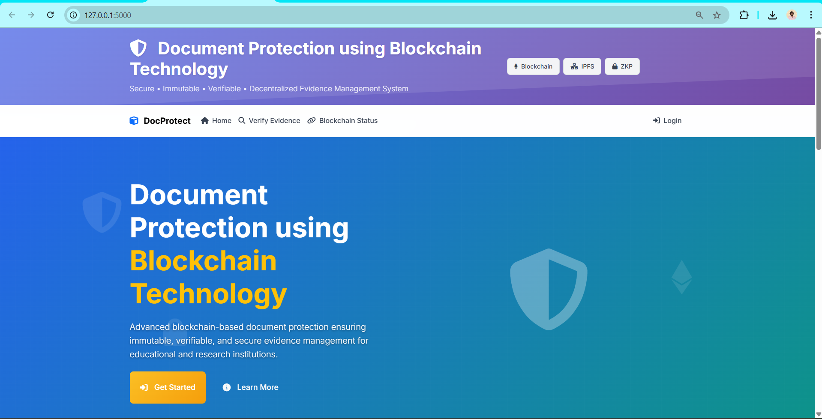
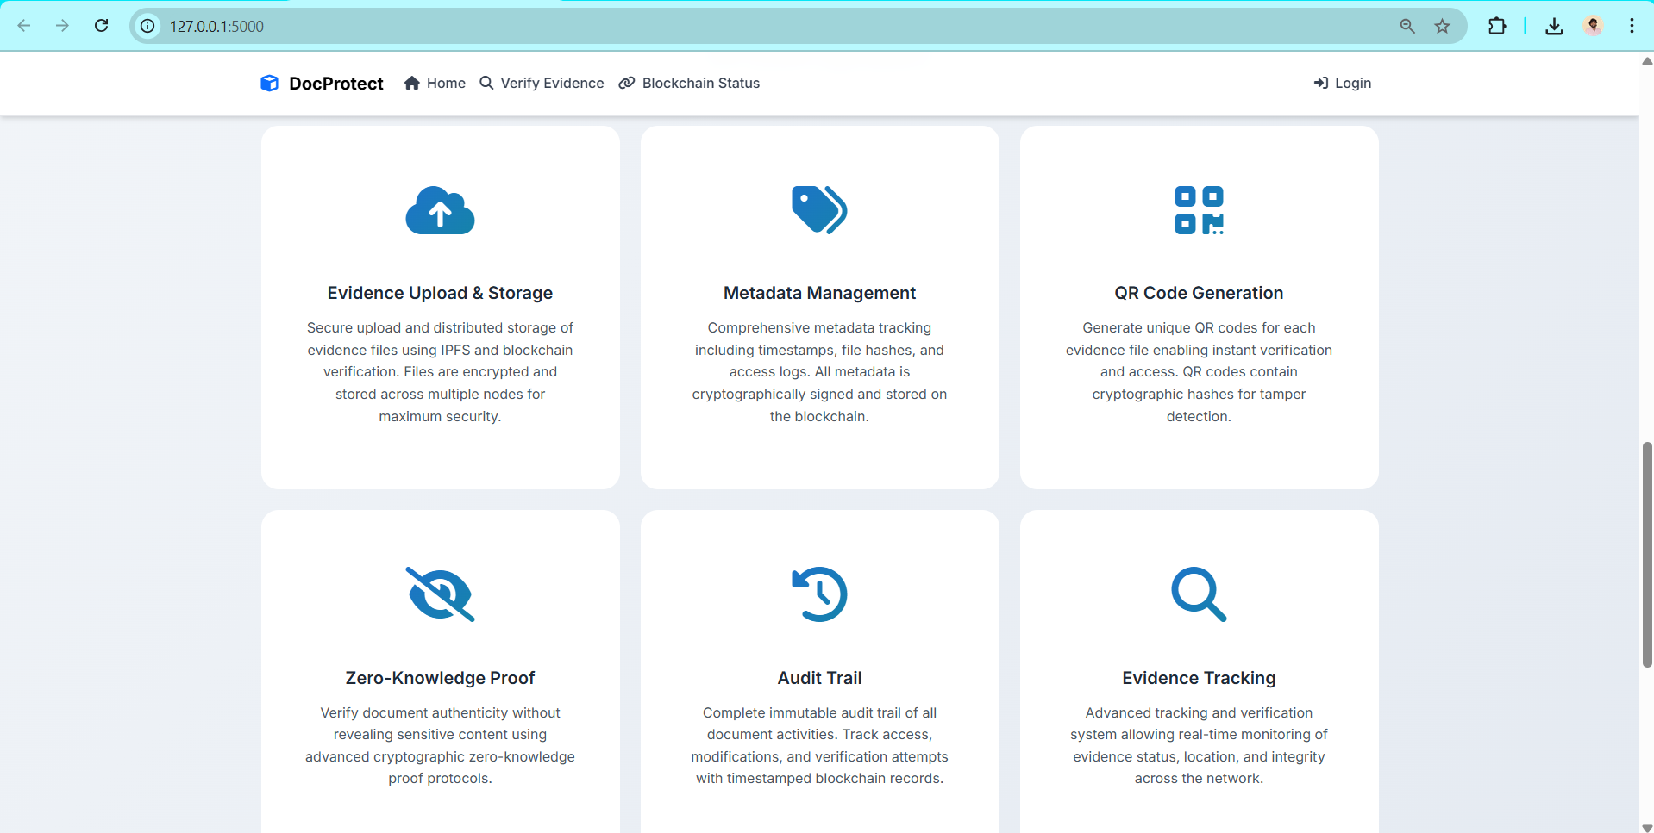

Future Enhancement
Integration with Multiple Blockchains
Currently, the system uses Ethereum (via Ganache) for document hash storage. In the future, it can be enhanced to support multiple blockchain networks, such as Hyperledger Fabric, Polygon, or Solana. This would improve scalability, reduce transaction costs, and provide interoperability between private and public blockchain networks. Users could select the network according to their requirements for faster verification or lower fees.

Decentralized Storage Expansion
While the current system optionally supports IPFS for decentralized storage, future versions could fully integrate IPFS, Filecoin, or Arweave for large-scale document storage. This would reduce dependency on local or centralized servers and ensure permanent, tamper-proof storage of documents, even if the main server is down.

Advanced Cryptography & Privacy Enhancements
Future enhancements can include homomorphic encryption, zero-knowledge proofs (ZKPs), and multi-party computation (MPC) to allow document verification without exposing sensitive content. This will make the system suitable for highly confidential documents, such as legal contracts, medical records, or research data, while maintaining privacy and compliance with regulations like GDPR or HIPAA.

AI-Based Document Validation
Integrating Artificial Intelligence and Machine Learning models could automatically detect anomalies or tampering in documents. For example, the system could check scanned PDFs or images for forgery, unauthorized modifications, or metadata inconsistencies, giving an additional layer of verification beyond blockchain validation.

Mobile Application Development
Developing a native or cross-platform mobile application would improve accessibility, allowing users to upload, verify, and manage documents directly from smartphones. Mobile QR scanning, push notifications for verification or upload confirmations, and offline storage capabilities could be included.

Enhanced User Management & Access Control
The system can be extended with multi-level access hierarchies for organizations. Features like delegated access, temporary verification links, approval workflows, and integration with enterprise authentication systems (e.g., LDAP, OAuth2) would improve control and auditing for large institutions.

Analytics and Reporting Dashboard
Adding real-time analytics and reporting features would allow administrators and investigators to visualize document uploads, verification statistics, user activities, and audit trails. Predictive insights can be generated to detect unusual patterns or potential misuse of the system.

Integration with External Systems
Future enhancements could include APIs for integration with university management systems, legal case management software, government portals, or research publication databases. This would automate document verification across multiple platforms and increase adoption.

Automated Notifications and Alerts
The system could include real-time email, SMS, or push notifications for key events such as document uploads, verification requests, or suspicious activity. Alerts for unauthorized access attempts or failed verification could enhance security and accountability.

Smart Contract Upgradability
Implementing upgradable smart contracts would allow improvements to blockchain functionality without losing previously stored document hashes. This ensures long-term maintainability while still preserving immutability for earlier records.

Support for Multimedia Documents
Currently, the system primarily supports text-based documents and images. Future versions could include video, audio, and interactive content verification with hashing and blockchain recording, expanding the use cases to digital media evidence management.

Scalability and Cloud Deployment
The system can be enhanced to support distributed cloud deployment using Docker or Kubernetes. This will allow handling higher volumes of documents and concurrent users, with load balancing, automatic backups, and high availability.

Enhanced UI/UX
Future enhancements could focus on dynamic dashboards, real-time verification animations, dark mode, multilingual support, and mobile-friendly interfaces, making the system more user-friendly for all types of users.

In essence, the future enhancements focus on scalability, security, automation, AI integration, and cross-platform accessibility, making the system robust, privacy-preserving, and suitable for large-scale institutional adoption.

References
• Nakamoto, S. Bitcoin: A Peer-to-Peer Electronic Cash System. 2008.
• Buterin, V. Ethereum White Paper: A Next-Generation Smart Contract and Decentralized Application Platform. 2014.
• Wood, G. Ethereum: A Secure Decentralized Generalized Transaction Ledger. Ethereum Project Yellow Paper, 2014.
• Crosby, M., Pattanayak, P., Verma, S., & Kalyanaraman, V. Blockchain Technology: Beyond Bitcoin. Applied Innovation Review, 2016.
• Li, X., Jiang, P., Chen, T., Luo, X., & Wen, Q. A Survey on the Security of Blockchain Systems. Future Generation Computer Systems, 2018.
• Szmigiera, M. Global blockchain technology market size 2023. Statista, 2023.
• Wood, T. & Zamani, M. Decentralized Storage: IPFS and Filecoin. IEEE Access, 2021.
• Christidis, K., & Devetsikiotis, M. Blockchains and Smart Contracts for the Internet of Things. IEEE Access, 2016.
• Mougayar, W. The Business Blockchain: Promise, Practice, and Application of the Next Internet Technology. Wiley, 2016.
• Swan, M. Blockchain: Blueprint for a New Economy. O’Reilly Media, 2015.
• Zheng, Z., Xie, S., Dai, H., Chen, X., & Wang, H. An Overview of Blockchain Technology: Architecture, Consensus, and Future Trends. IEEE International Congress on Big Data, 2017.
• Tapscott, D., & Tapscott, A. Blockchain Revolution: How the Technology Behind Bitcoin and Other Cryptocurrencies is Changing the World. Penguin, 2016.
• Ethereum Foundation. Solidity Documentation. https://docs.soliditylang.org
• IPFS Team. IPFS Documentation. https://docs.ipfs.io
• Flask Project. Flask Web Framework Documentation. https://flask.palletsprojects.com
• Python Software Foundation. Python 3 Official Documentation. https://docs.python.org/3/
• Web3.py Documentation. Python library for Ethereum blockchain interaction. https://web3py.readthedocs.io
• QRCode Library for Python. qrcode module documentation. https://pypi.org/project/qrcode/
• Kshetri, N. Blockchain’s Roles in Strengthening Cybersecurity and Protecting Privacy. Telecommunications Policy, 2017.
• Casino, F., Dasaklis, T. K., & Patsakis, C. A Systematic Literature Review of Blockchain-Based Applications: Current Status, Classification and Open Issues. Telematics and Informatics, 2019.

